A COMPREHENSIVE TRAINING ON HPE’S AI

SOLUTION OFFERINGS: BUILD, DEPLOY AND ACCELERATE

HPE Official Curriculum

CloudThat

1/2/2023

Learner’s Lab Guide

**Index**

|  |  |  |  |
| --- | --- | --- | --- |
| **Sr** | **Topic** | **Title** | **Page No** |
| 1 | Launch VM instance in GCP Compute Enine |  |  |
|  | 1.1 Launch VM Instance - Scratch | Appendix 1a | 2-9 |
|  | 1.2 Launch VM Instance – From Image | Appendix 1b | 10-18 |
| 2 | Connect to GCP VM Instance | Appendix 2 | 19-15 |
|  | 2.1 With SSH access |  | 19-21 |
|  | 2.2 Connect using Remote Desktop |  | 22-25 |
| 3 | Install Smartsim on GCP VM Instance | Appendix 3 | 26-19 |
| 4 | Install Pachyderm and Seldon core on GCP Ubuntu VM | Appendix 4 | 20-33 |
| 5 | Install Swarm Learning on GCP Ubuntu VM | Appendix 5 | 34-55 |

**Appendix 1a**

**Launch VM Instance**

Step 1: Use the URL https://console.cloud.google.com/shared with you for Login to GCP console. After successful login you will get GCP Management Console Page as follows. Open Compute Engine Instances tab.

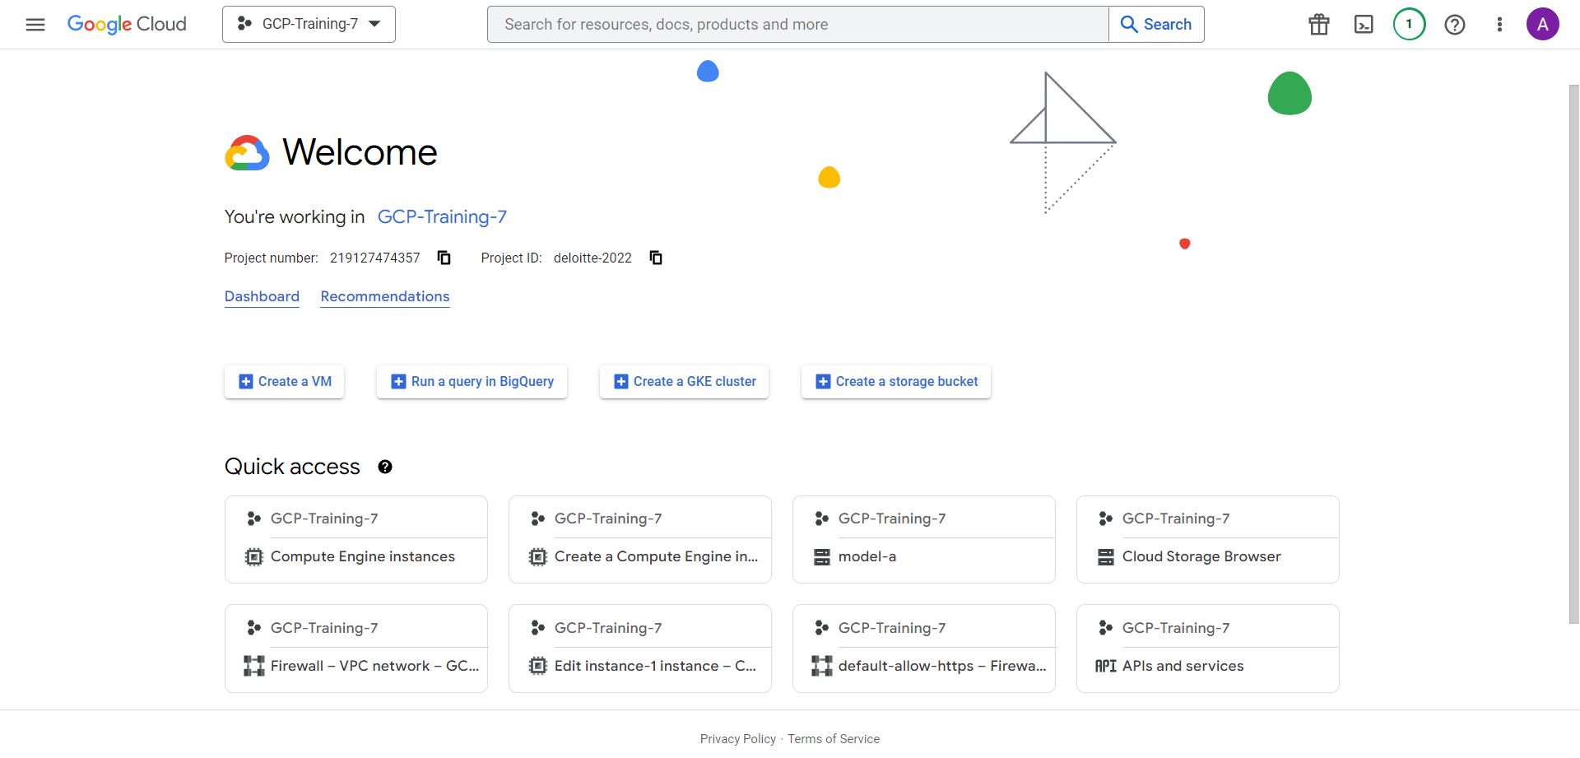

Or you can select from left menu

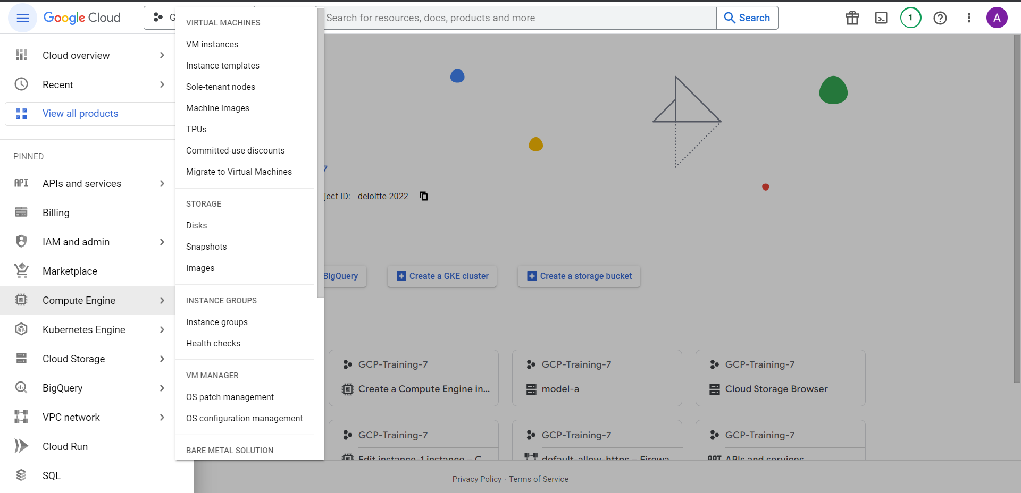

Step 2: You will be redirected to VM Dashboard. Click on the ‘create instance’ button

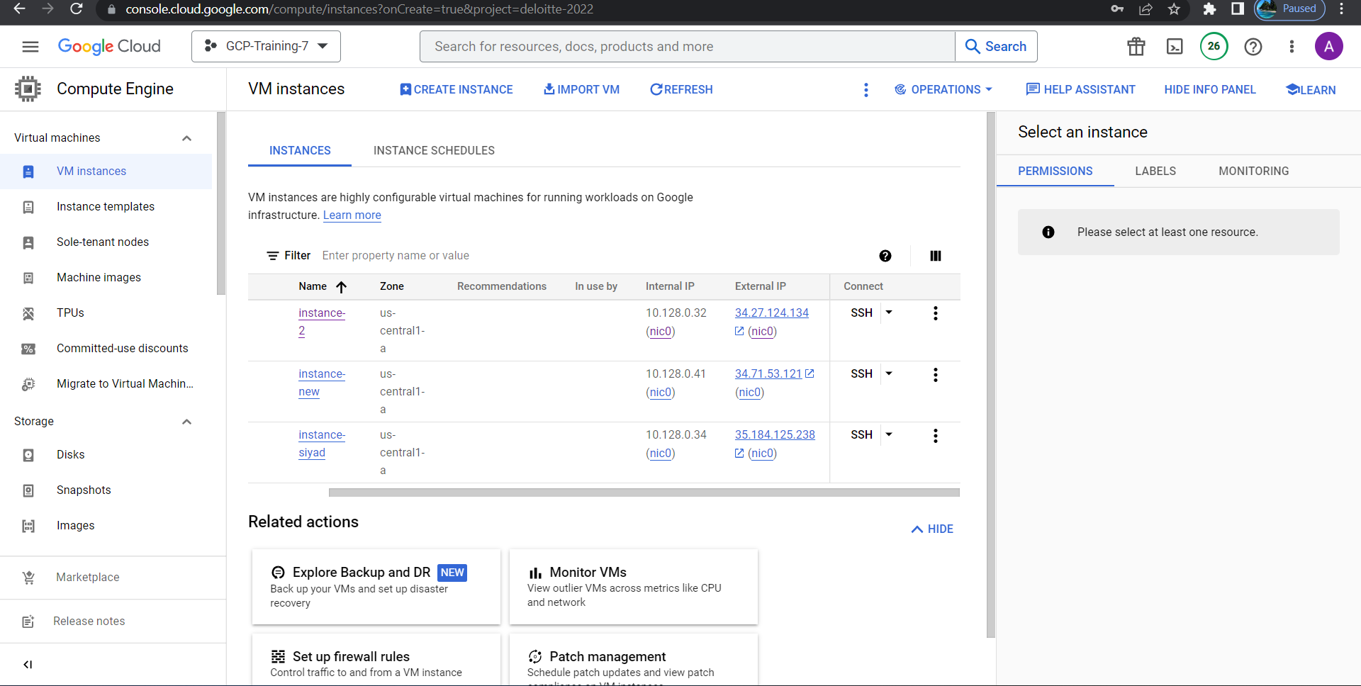

Step 3: It will take you to Instance creation page as follows. Specify the name, region, and size of the VM.

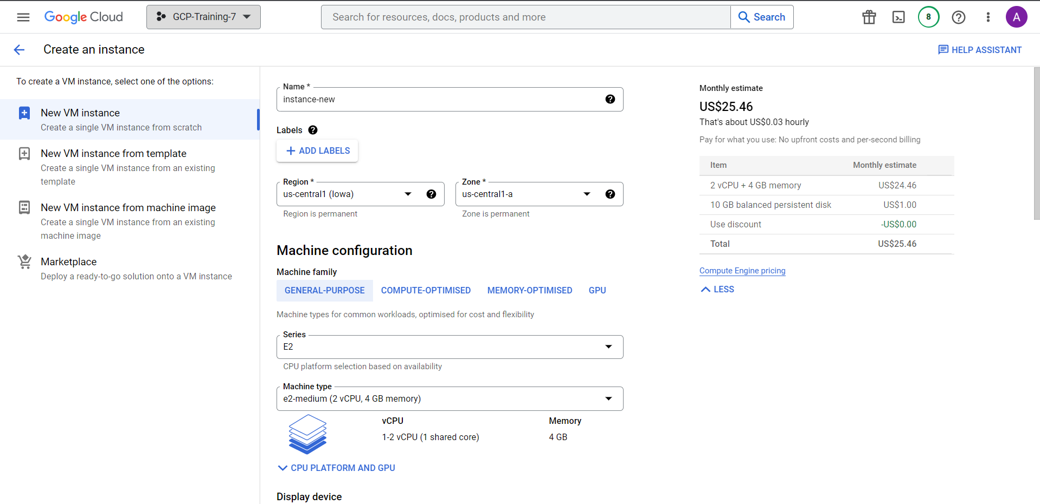

Step 4: Click on the change button on ‘boot disc’ and specify the OS requirements

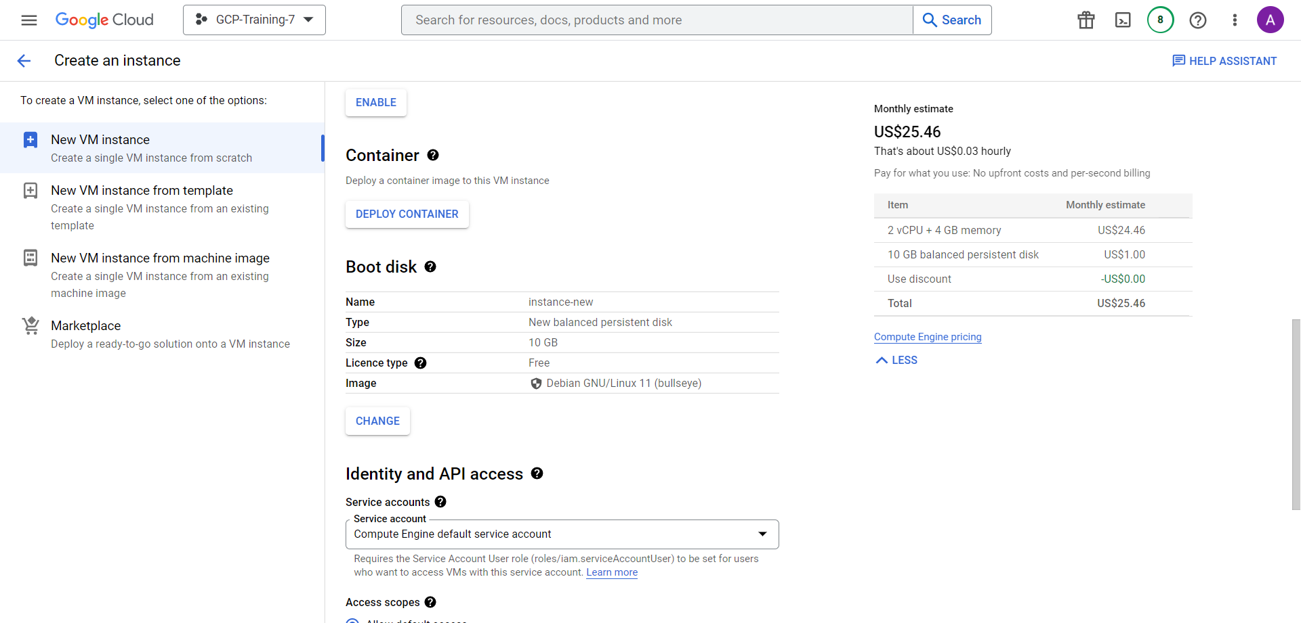

Step 5: It will take you to Launch an Boot disk page. Here you must provide following info

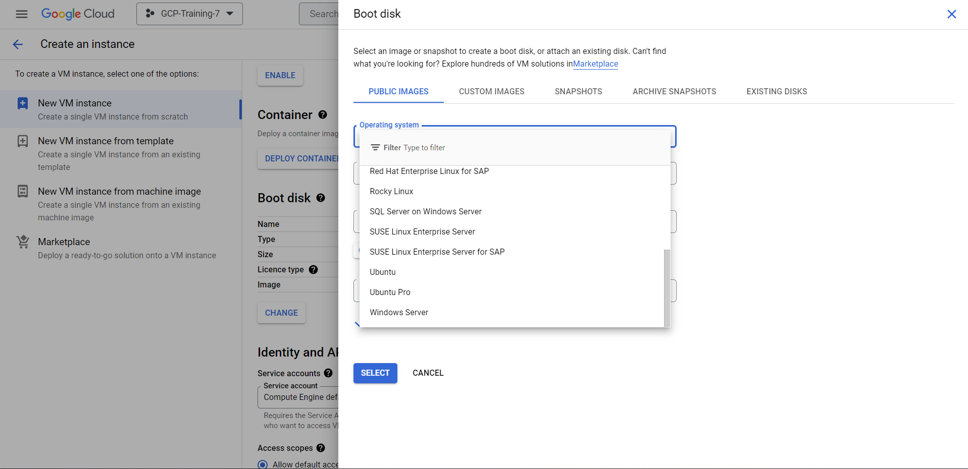

Select Ubuntu OS from tiles and Ubuntu 20.04LTS image for x86/64 from dropdown as follows

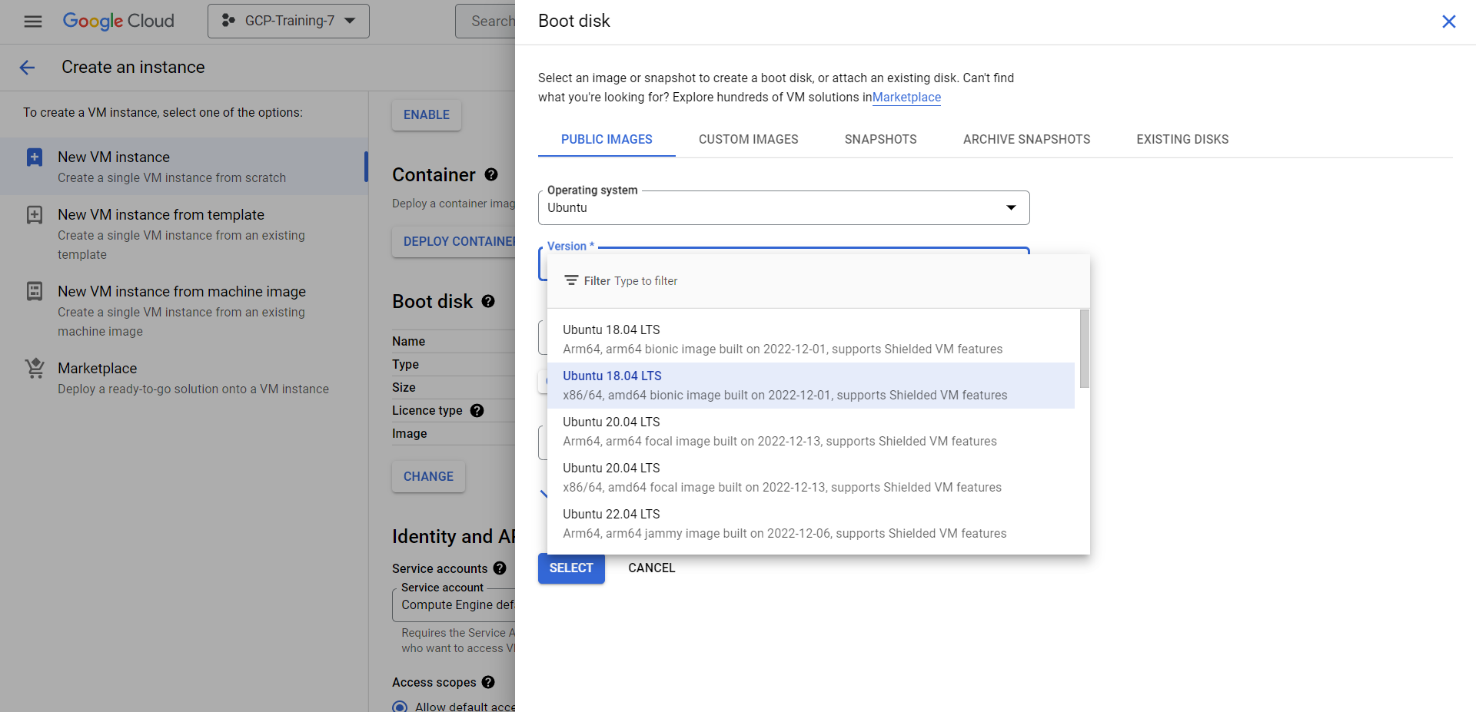

Step 6: Choose the boot disk size 50GB

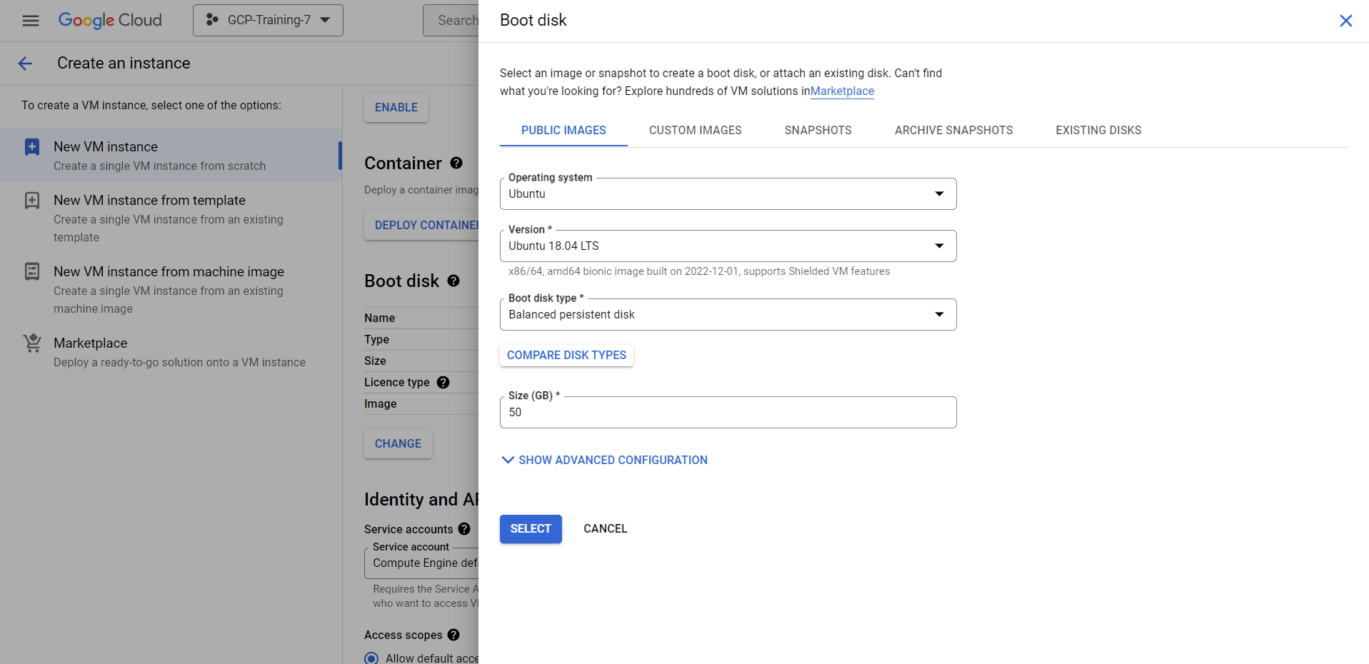

Step 7: Enable ‘allow HTTP and HTTPS traffic’. Keep everything else default and click on create

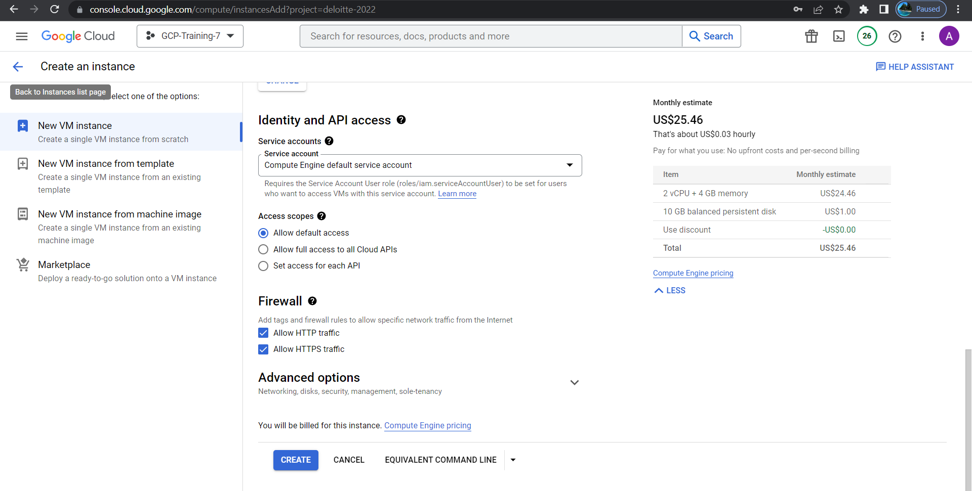

Step 8: On the VM Instances page, check the status of the vm you have created.

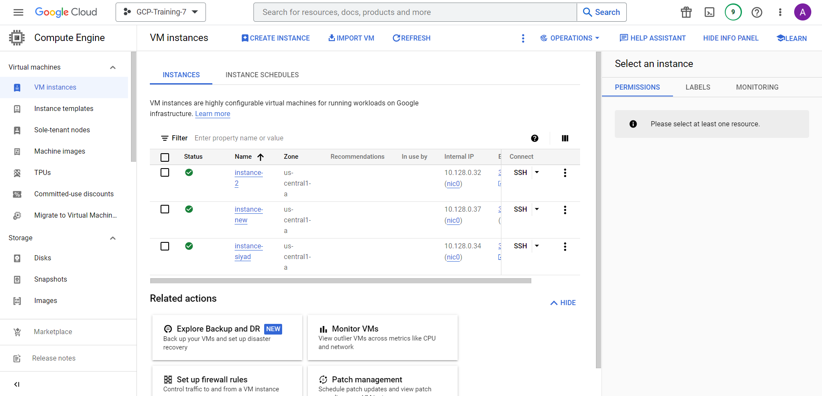

Also, the internal and external IP addresses can also be visible in the dashboard



**Appendix 1b**

**Launch VM Instance – from Image**

Step 1: Use the URL https://console.cloud.google.com/shared with you for Login to GCP console. After successful login you will get GCP Management Console Page as follows. Open Compute Engine Instances tab.



Step 2: Select the ‘images’ from the left panel

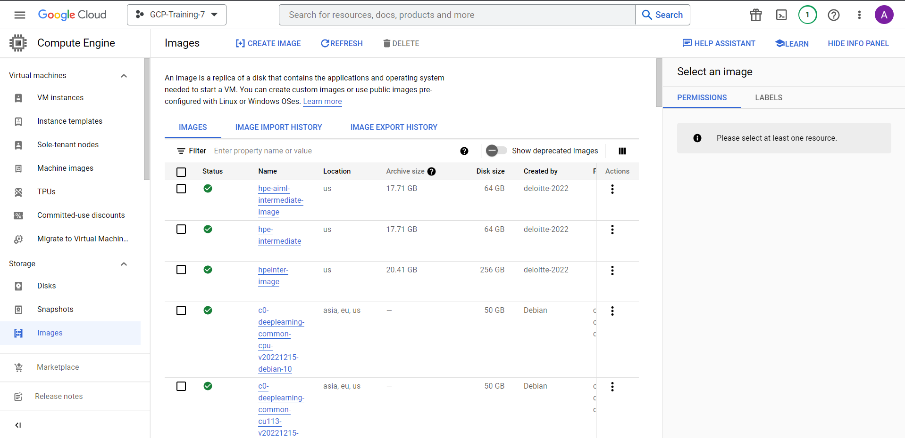

From the menu also you can select images



Step 3: Select the image you wish to create VM(Please wait for the trainer’s instruction for the correct image name)

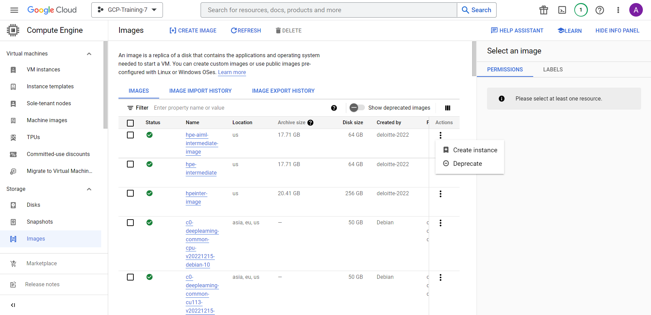

Step 4: Follow the creation steps, name, and size of the VM.

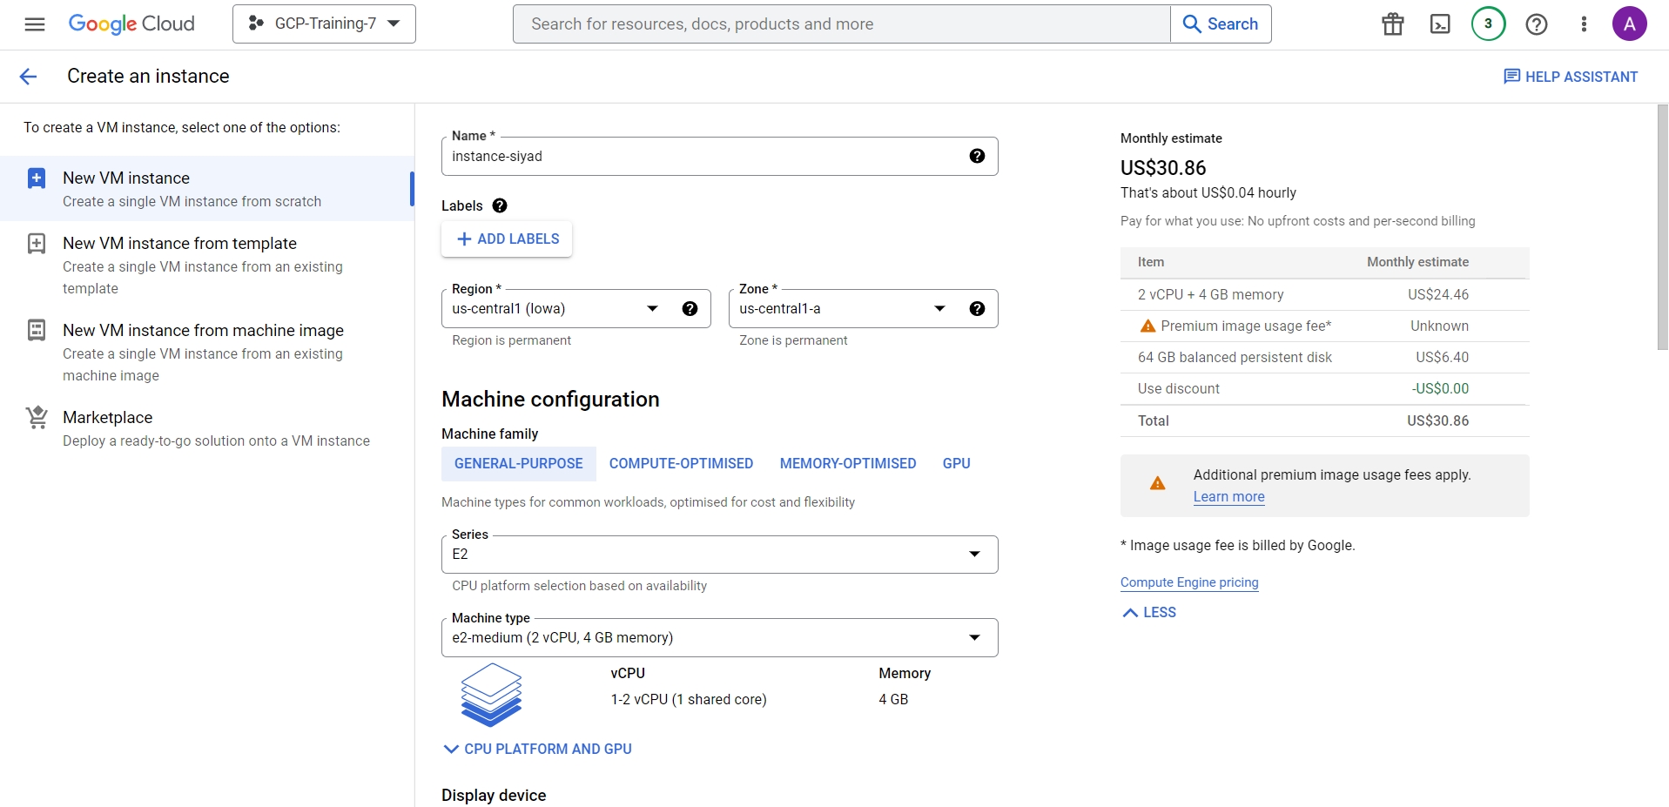

Step 6: Enable ‘allow HTTP and HTTPS traffic’. Keep everything else default and click on create



Step 7: On the VM Instances page, check the status of the vm you have created.



Also, the internal and external IP addresses can also be visible in the dashboard



**Appendix 2**

**Connect to GCP VM Instance**

1. **With SSH access**

Step 1: Login to GCP VM Instances console with credentials and click on the SSH



Step 2: The SSH based CLI access will be available without any further authentication

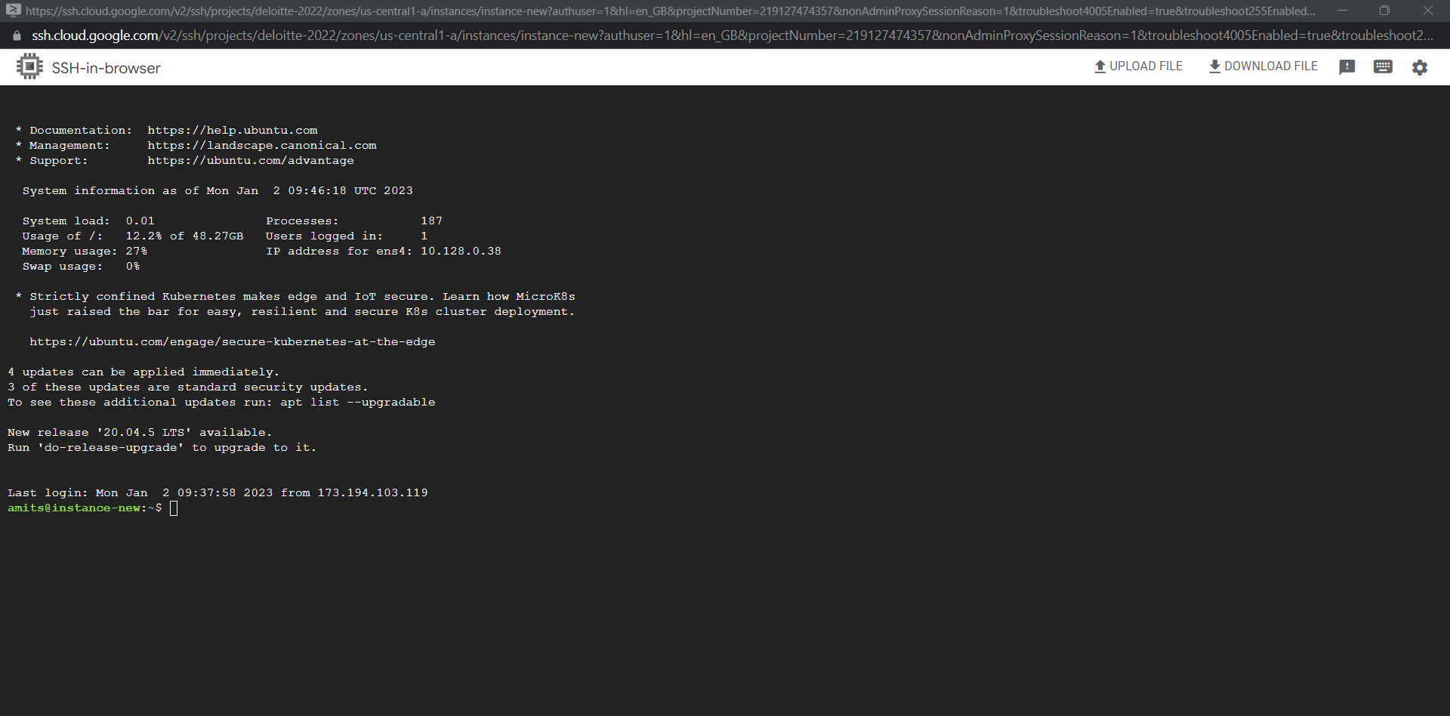

1. **With Remote Desktop Access**

Step 1: Login to GCP VM Instances console with credentials and click on the SSH



Step 2: The SSH based CLI access will be available without any further authentication



Step 3: Run following commands in terminal to update the package manager data and install wget and tasksel. Wget is a free software package for retrieving files using HTTP, HTTPS, FTP and FTPS, the most widely used Internet protocols. Tasksel is a Debian/Ubuntu tool that installs multiple related packages as a coordinated “task” onto your system.

sudo apt update

sudo apt install --assume-yes wget tasksel

Step 4: Download and install the Debian Linux Chrome Remote Desktop installation package:

wget https://dl.google.com/linux/direct/chrome-remote-desktop_current_amd64.deb

sudo apt-get install --assume-yes ./chrome-remote-desktop_current_amd64.deb

Step 5: Set up an Ubuntu desktop environment in the VM instance by Ubuntu desktop environment

sudo tasksel install ubuntu-desktop

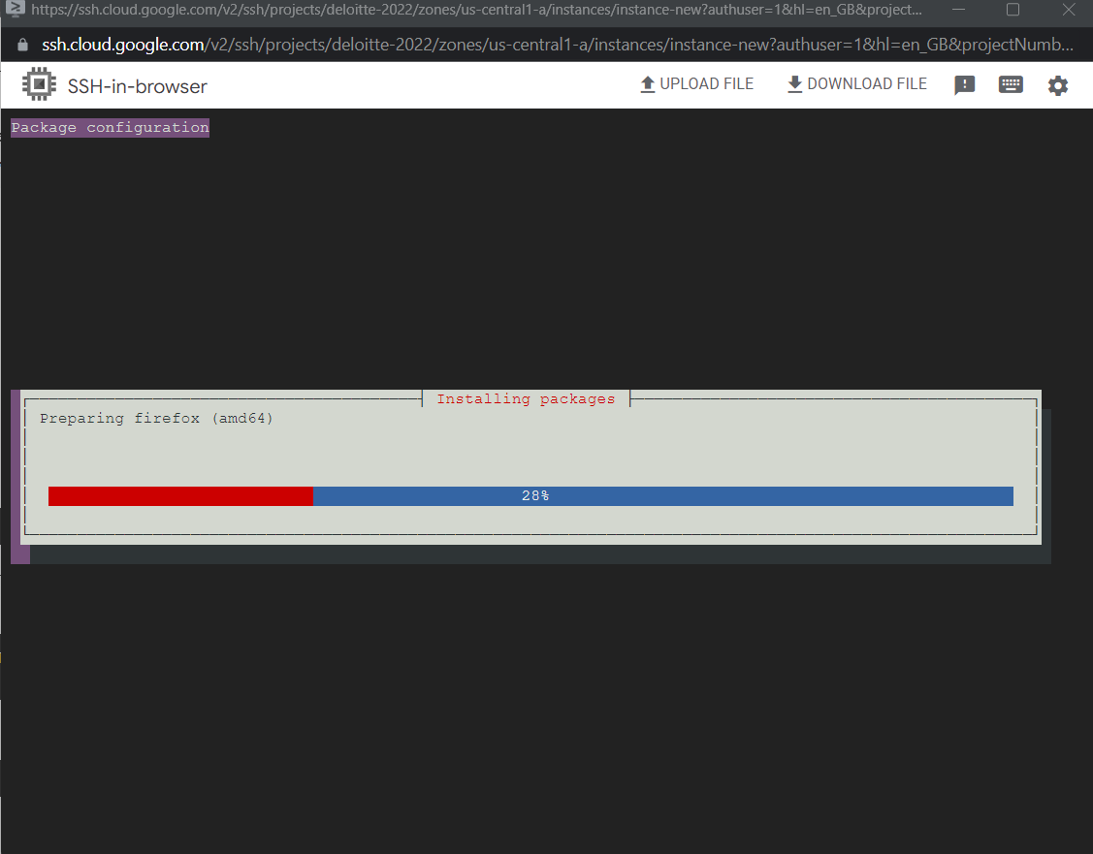

Step 6: Set your Chrome Remote Desktop session to use Gnome, which is the default desktop environment for Ubuntu

sudo bash -c ‘echo “exec /etc/X11/Xsession /usr/bin/gnome-session” > /etc/chrome-remote-desktop-session’

Step 6: Reboot your Ubuntu VM instance.

sudo reboot

Step 7: Configure the Chrome Remote Desktop service and Connect to your Ubuntu Desktop. On your local computer, using the browser, go to the Chrome Remote Desktop command line setup page:

https://remotedesktop.google.com/headless

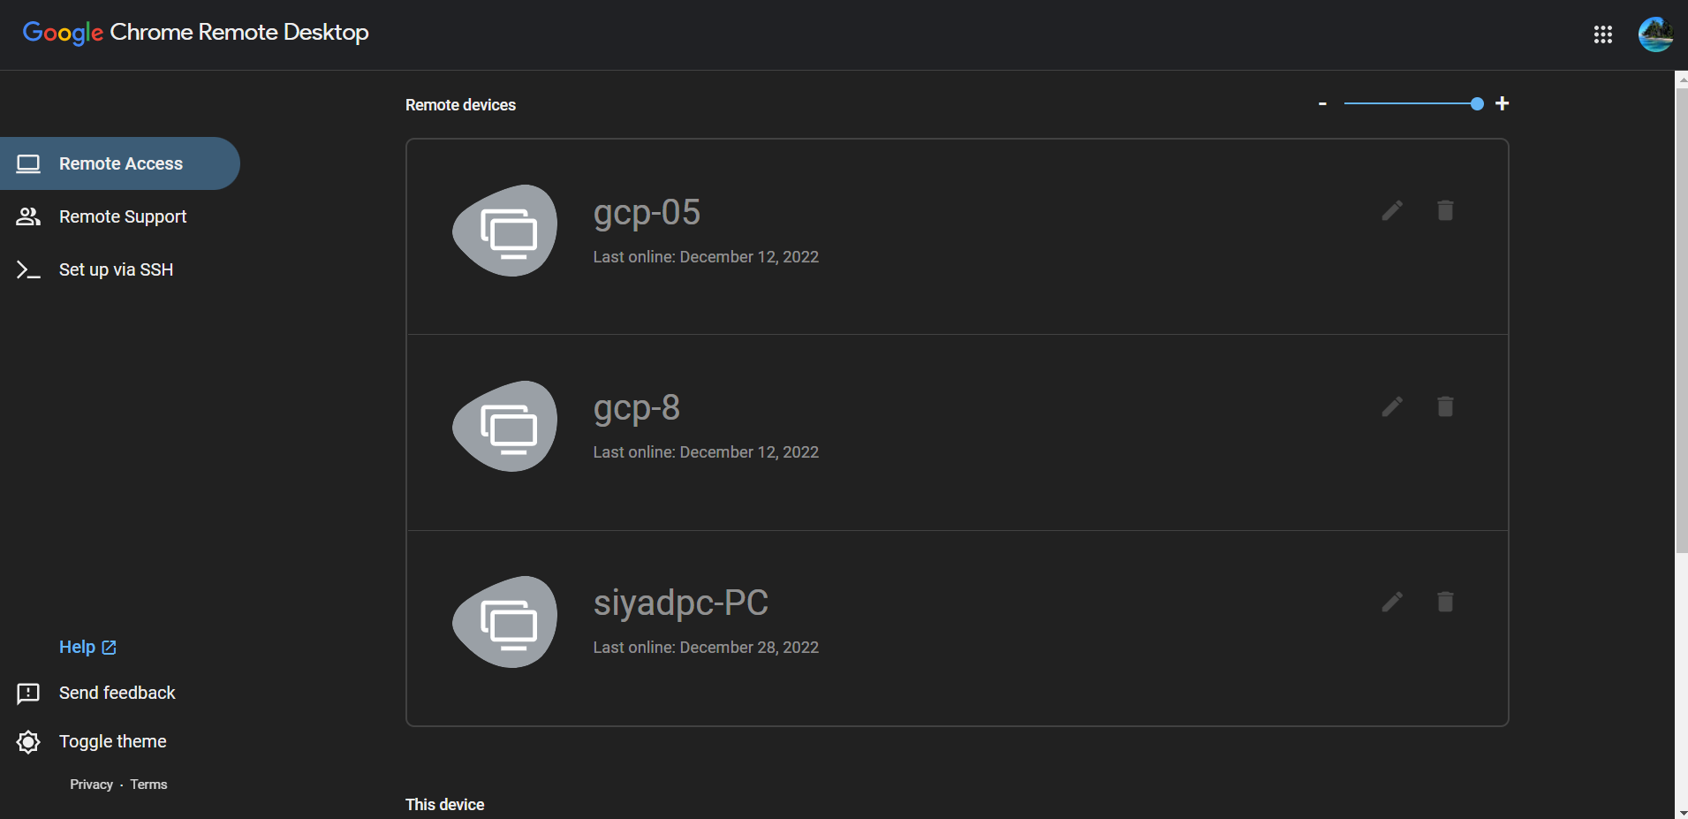

Step 8: Select Set up via SSH. On the Set up another computer page, click Begin.

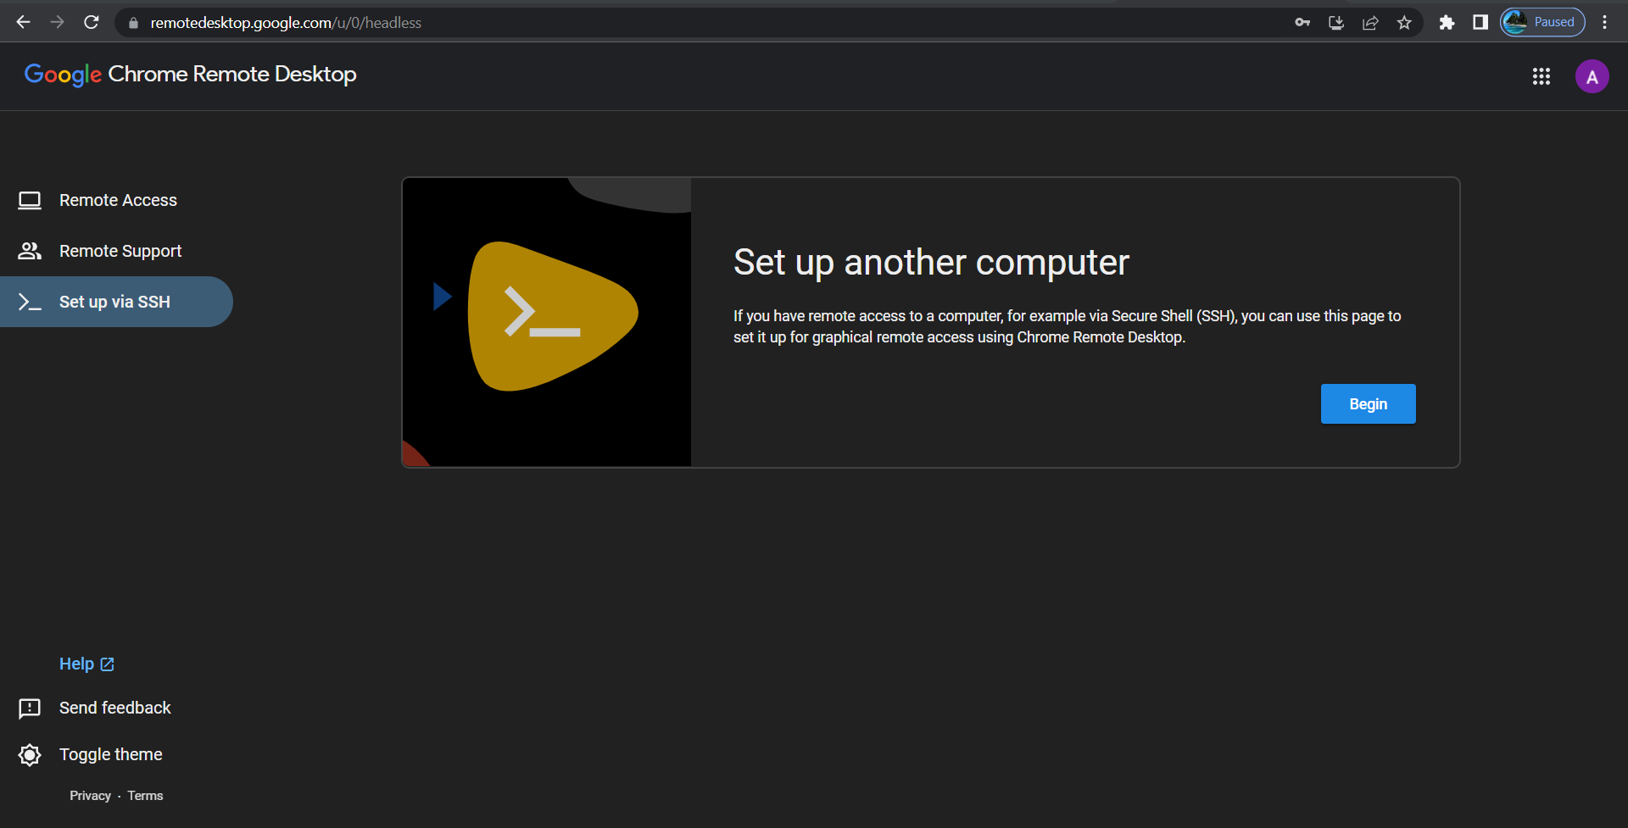

Step 9: Click Next. You already installed the Chrome Remote Desktop on the remote computer in STEP2(Install and configure the Chrome Remote Desktop service on the VM instance)

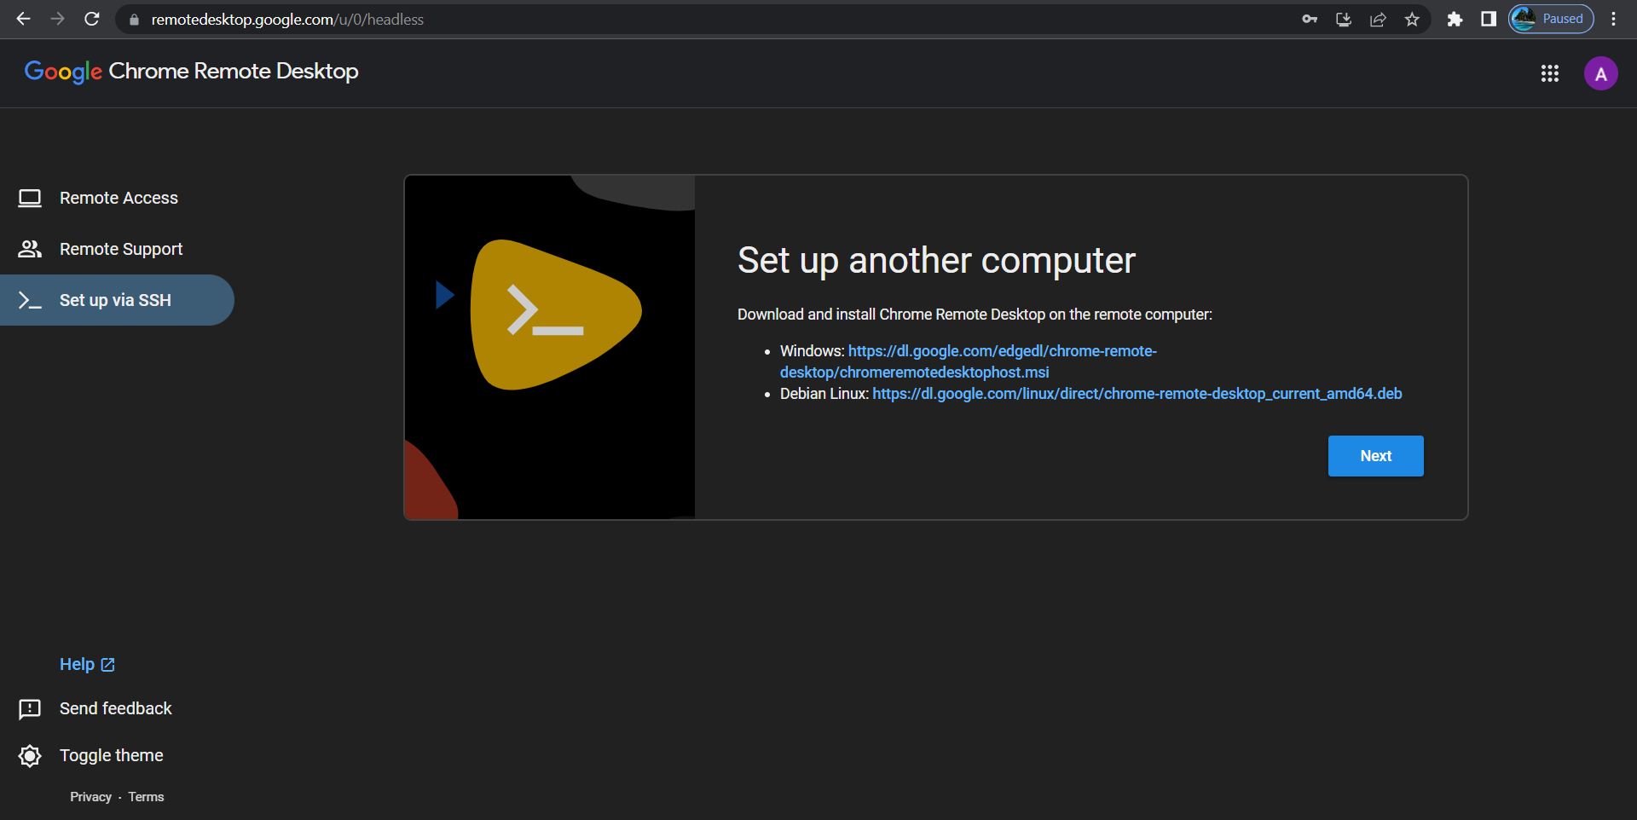

Step 10: Click Authorize.

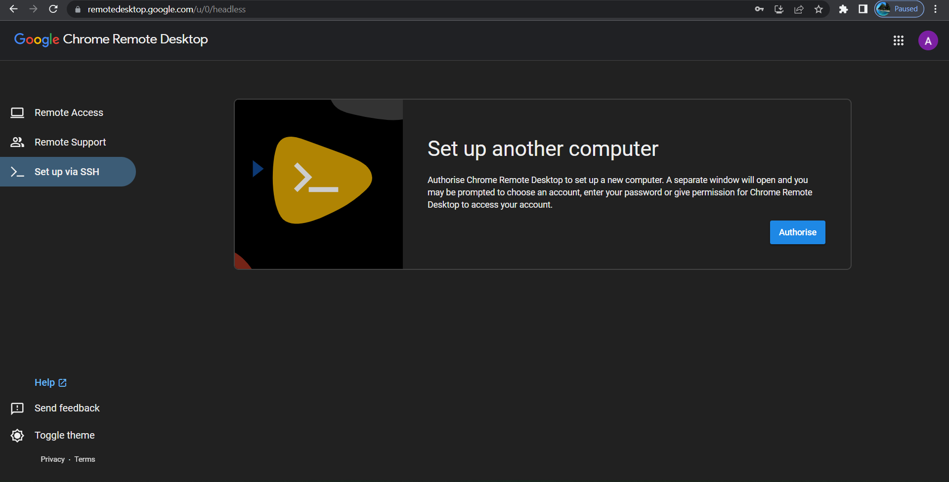

Step 11: Now you get the command to set up and start the Chrome Remote Desktop service on your VM instance. Copy the command for Debian Linux.

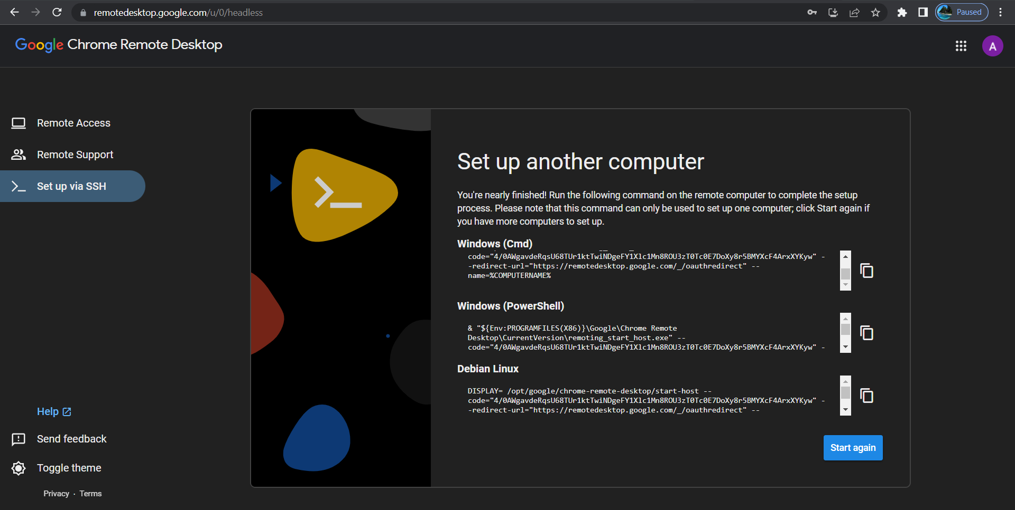

Step 12: Paste the command to the SSH window that connects to your VM instance. Run the command.

Enter a 6 digit PIN when prompted. This PIN will be used when you log into the VM instance from your Chrome. If you see errors like Fail to read or No net_fetcher, ignore them.

Step 13: Click on Remote Access and click on the instance running. Provide the PIN you have provided during the set up.

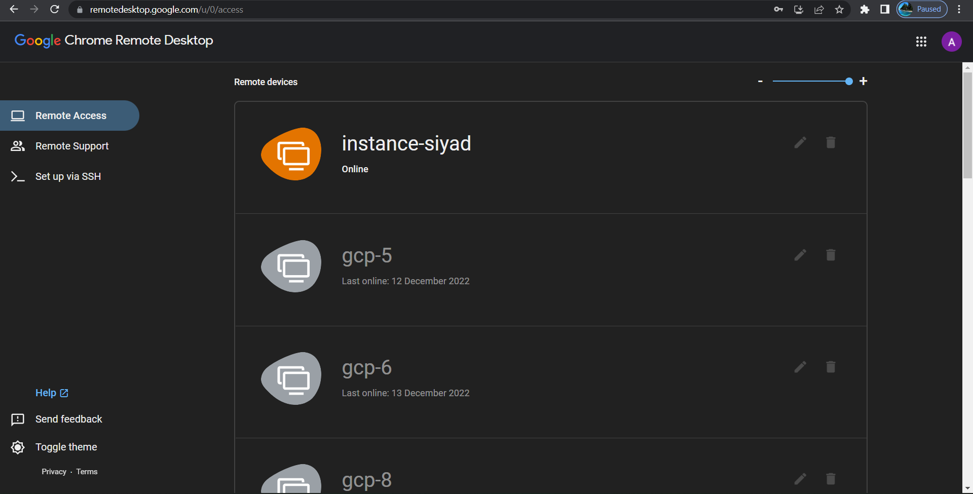

Step 14: Click on Remote Access and click on the instance running. Provide the PIN you have provided during the set up.

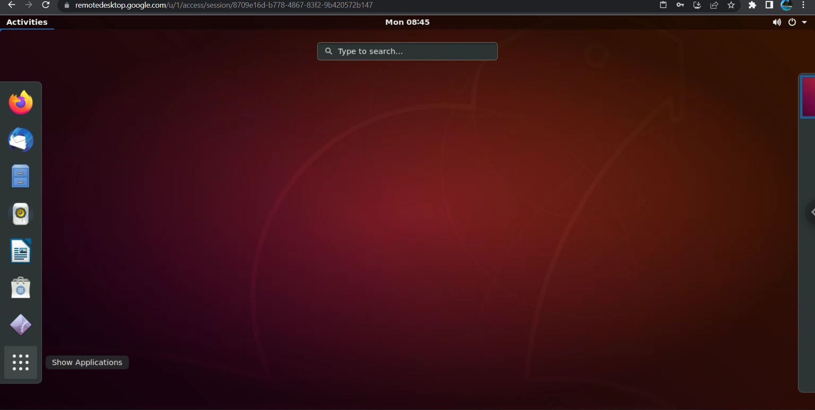

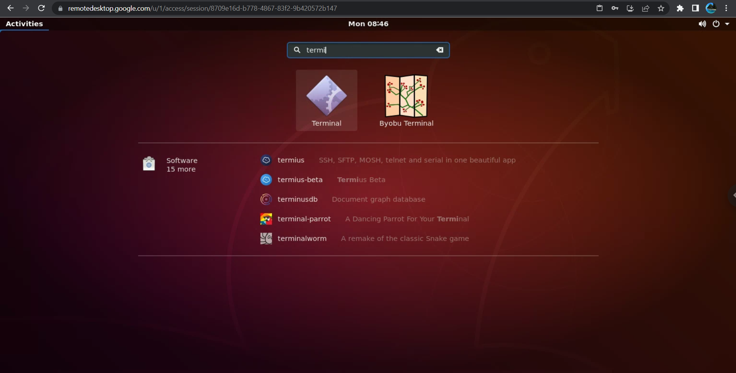

**Appendix 3**

**Install Smartsim on GCP VM Instance**

**Step 1: Create Ubuntu 20.04LTS GCP VM.**



Open the SSH tab of the instance you have created



**Step2: - Install necessary packages**

sudo apt update

sudo apt install software-properties-common

**Install Python3.8**

sudo apt -y install python3.8

python3 --version

**Install Python Package Installer**

sudo apt install python3-pip python3-dev

sudo apt -y install pip

sudo -H pip3 install --upgrade pip

**Step3: -** Install necessary Libraries

pip install matplotlib

pip install tensorflow

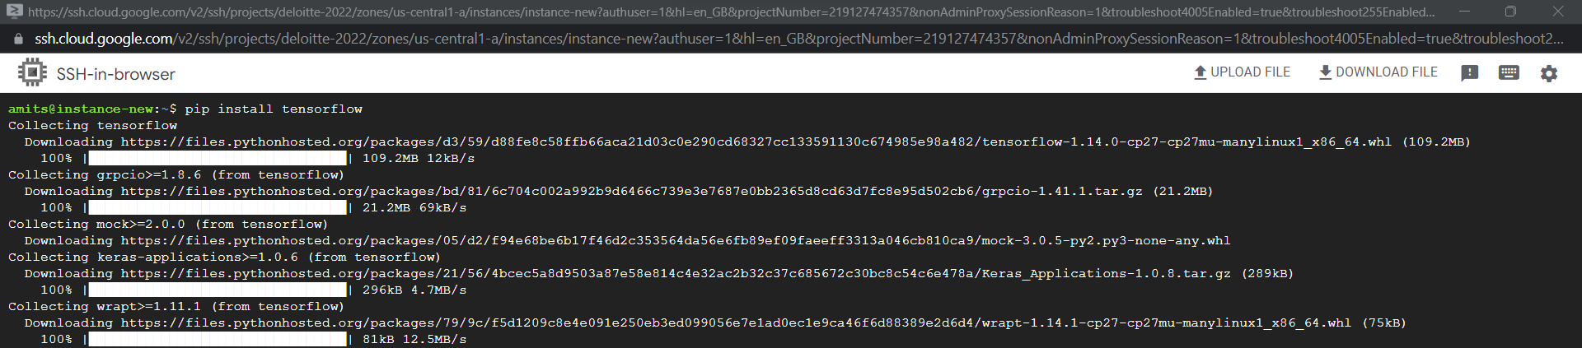

**Step 4: -** Install SmartSim

pip install smartsim

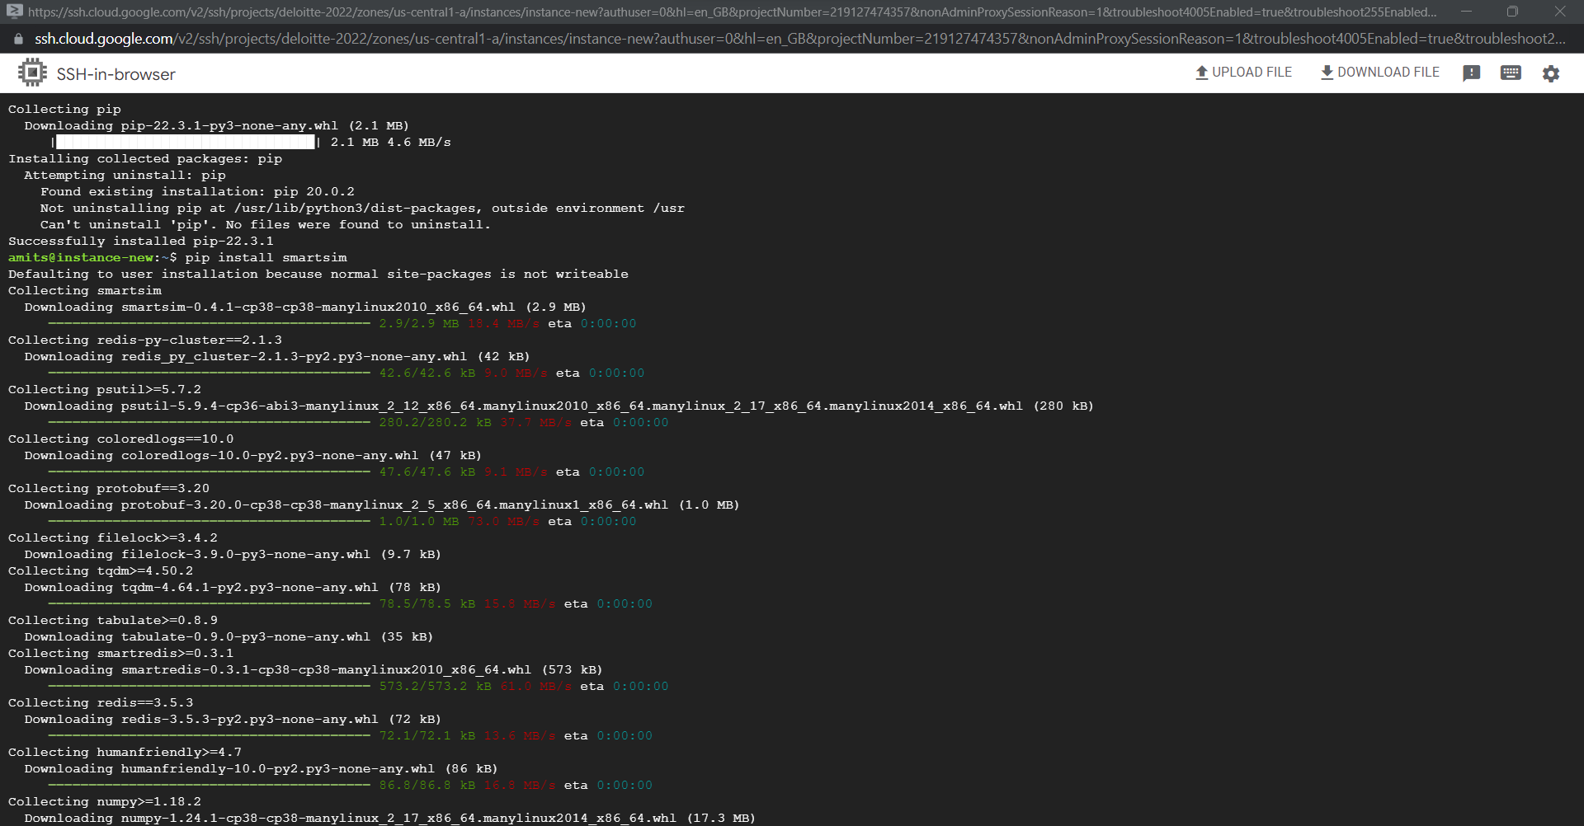

**Step 5: -** install git-lfs

sudo apt-get install git-lfs

**Step6: -** InstallCMAke

sudo snap install cmake –classic

Reboot the system and continue with step7

**Step 7: -** Build smart

smart build --device cpu --no_pt

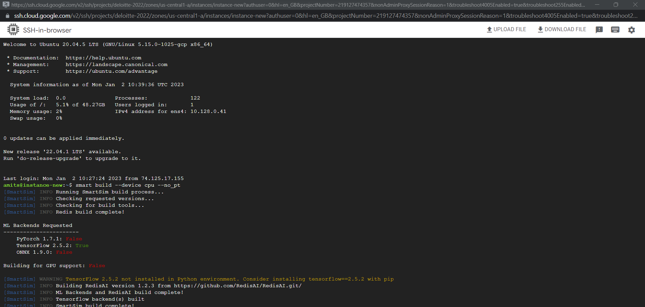

**Step 8: -** install jupyter Lab

pip install tensorflow==2.5.2

pip install Jinja2==3.0.3

pip install markupsafe==2.0.1

pip install jupyter

**Step9: -** Open jupyter notebook

If you are in RDP run jupyter notebook command and open smartsim notebooks and execute

Jupyter notebook -–ip=*

(Allow the port number 8888 in firewall rules)

Open <publicip>:8888 on browser

**Step10: -** Run the Lab4a and Lab 4b ipynb notebooks. Then disconnect and reconnect jupyter lab and execute Lab 5 and Lab 6 ipynb notebooks

**Appendix 4**

**Install Pachyderm and Seldon Core on GCP Ubuntu VM**

Step 1- Connect to your GCP VM instance using SSH

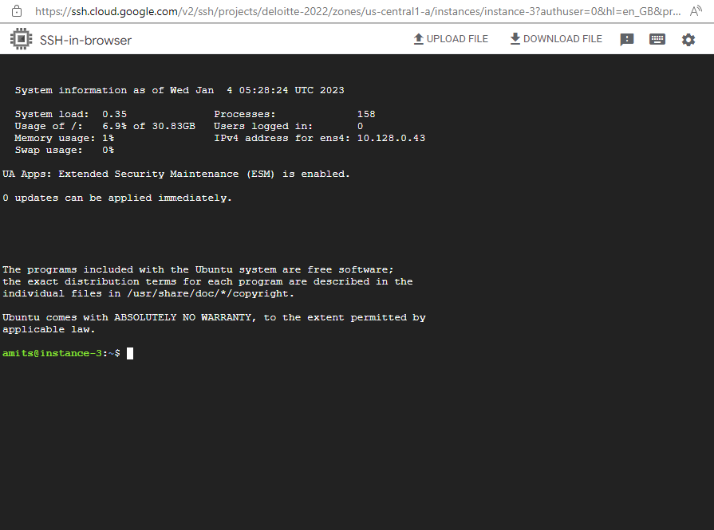

Step 2- Install Pachyderm

1. Execute following commands one by one

chmod +x k8s_master_gce-v1.24.4-Seldon-Pachd.sh

sudo ./k8s_master_gce-v1.24.4-Seldon-Pachd.sh

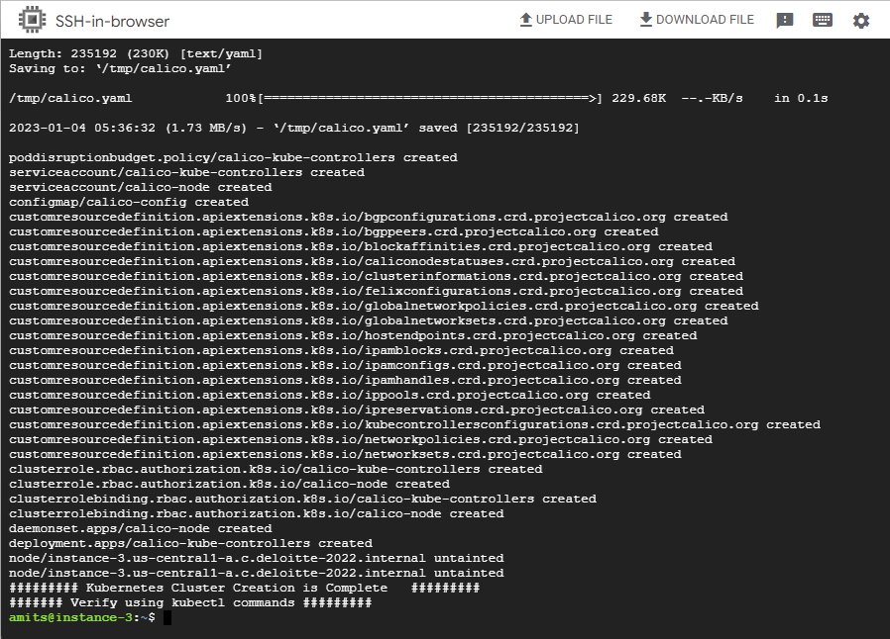

sudo su – ubuntu

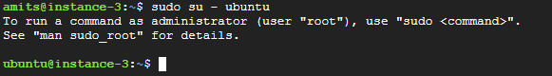

cd ~

kubectl get nodes

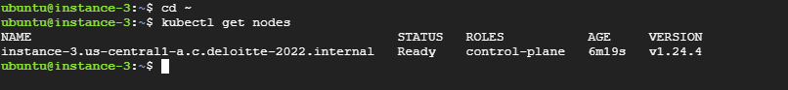

curl -fsSL -o get_helm.sh <https://raw.githubusercontent.com/helm/helm/main/scripts/get-helm-3>

ls



chmod 700 get_helm.sh

./get_helm.sh

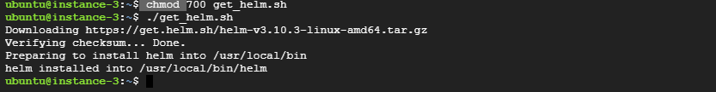

curl -o /tmp/pachctl.deb -L https://github.com/pachyderm/pachyderm/releases/download/v2.3.9/pachctl_2.3.9_amd64.deb && sudo dpkg -i /tmp/pachctl.deb

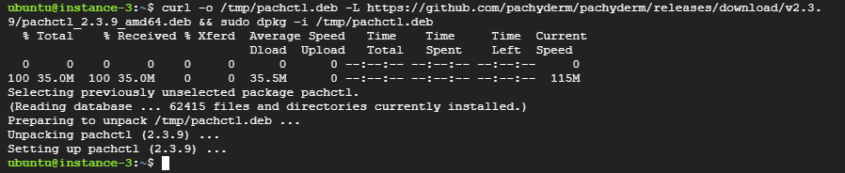

pachctl version --client-only



helm repo add pach <https://helm.pachyderm.com>

helm repo add rimusz <https://charts.rimusz.net>

helm repo update

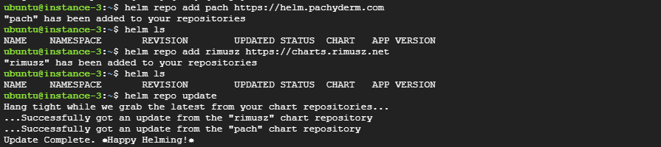

helm upgrade --install hostpath-provisioner --namespace kube-system rimusz/hostpath-provisioner

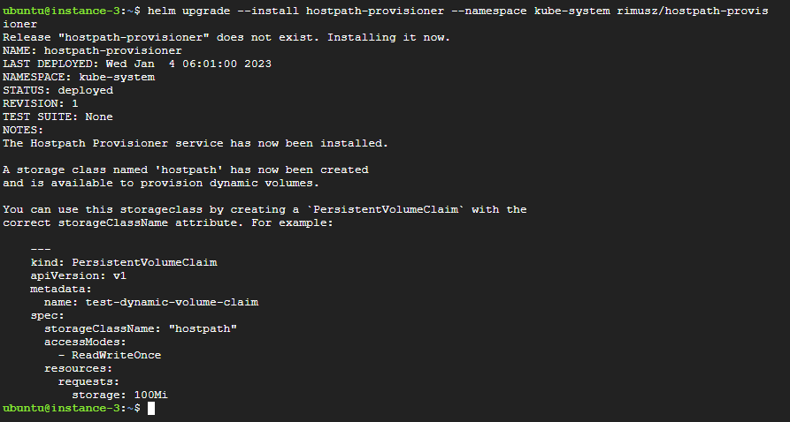

kubectl get sc

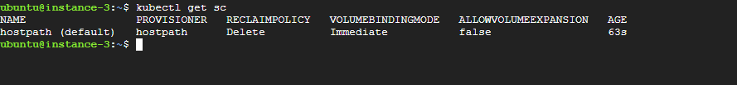

kubectl get pods -n kube-system

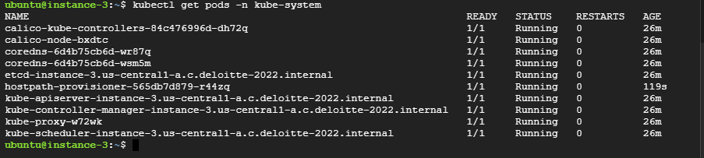

kubectl apply -f test-pvc.yaml



kubectl get pvc

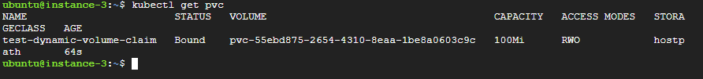

helm install --wait --timeout 10m pachd pach/pachyderm --set proxy.enabled=true --set proxy.service.type=NodePort --set deployTarget=LOCAL

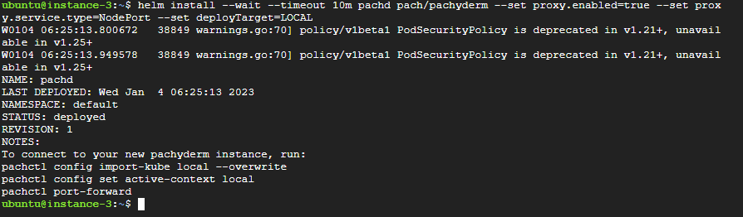

pachctl config import-kube local –overwrite

pachctl config set active-context local

kubectl get svc

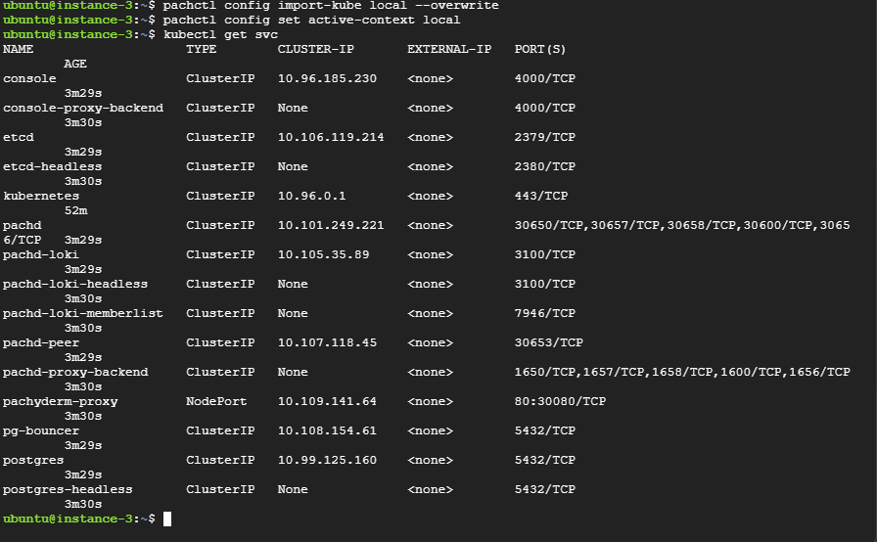

Open Node port in firewall

1. Goto GCP console and click on instance

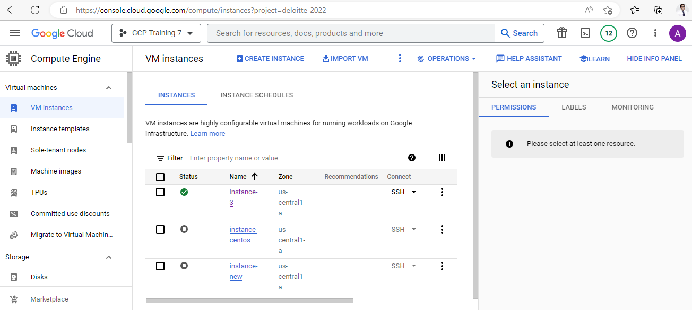



1. Click on nic0

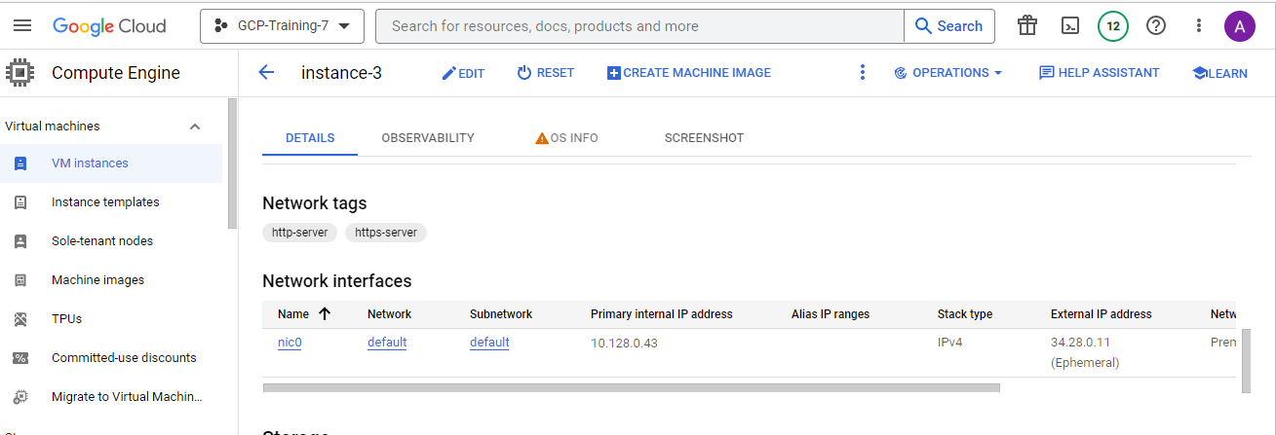



1. Click on expand mode

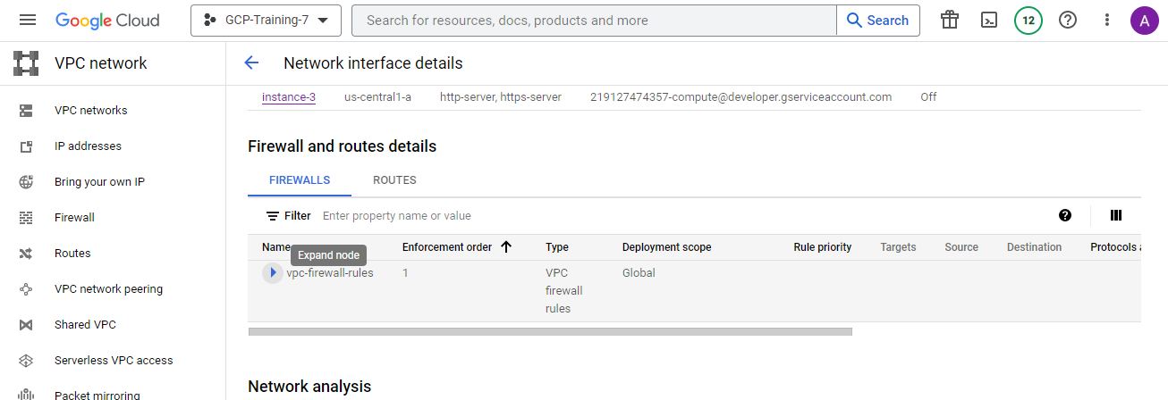



1. Click on all default-allow http

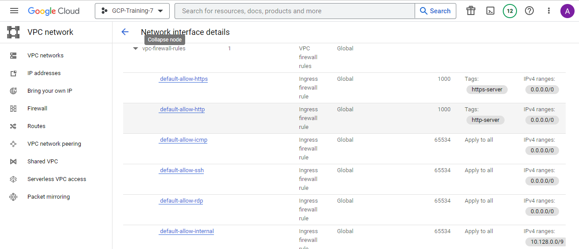

1. Click on EDIT

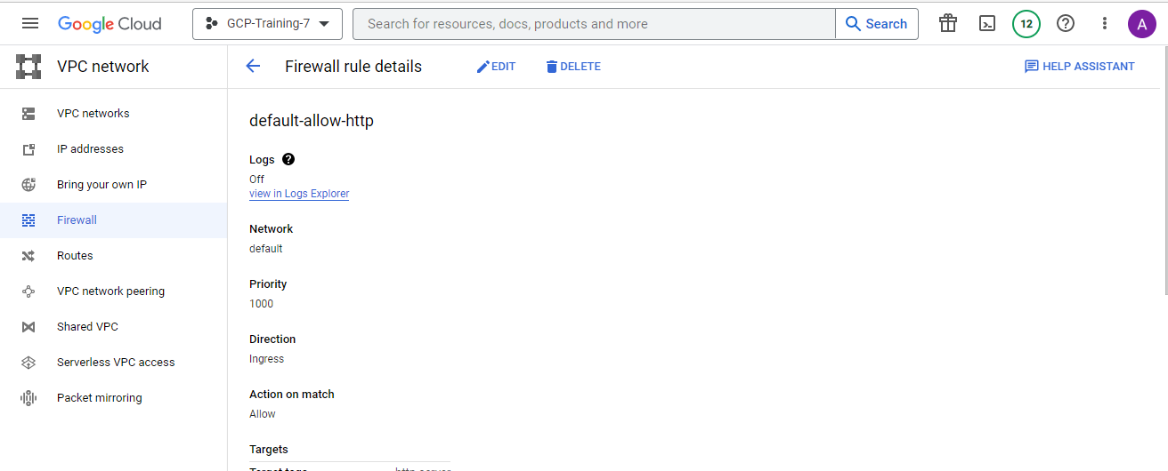



1. Click on Allow All if not selected and Click on SAVE

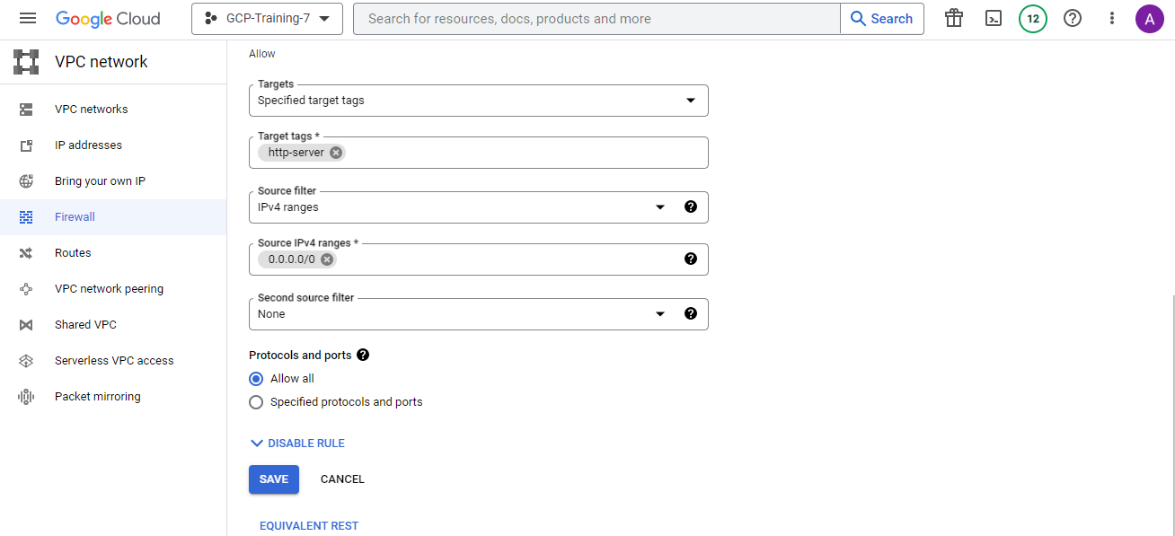



1. Copy external IP and paste in address bar of browser with port 30080

Ex. 34.28.0.11:30080

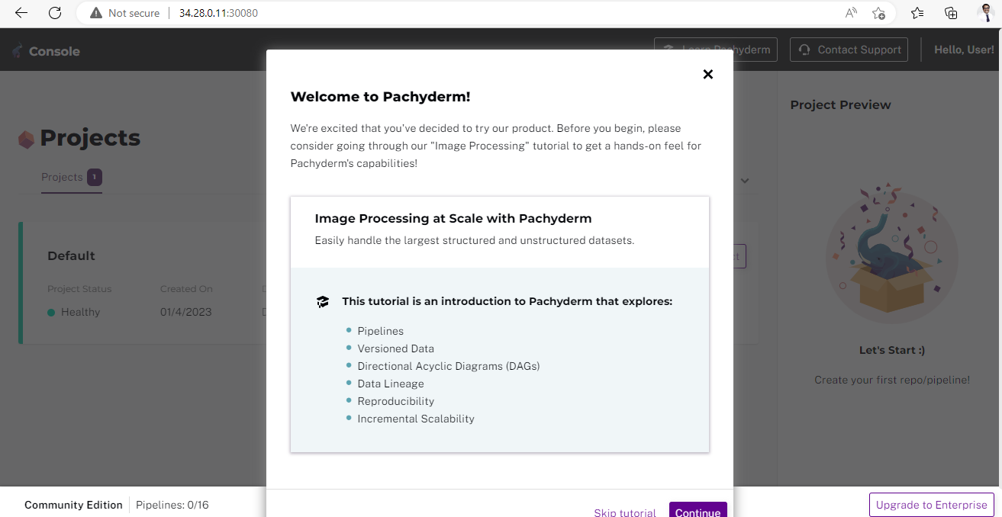

Step 3: INSTALL SELDON CORE

1. Download Istio

For Linux and macOS, the easiest way to download Istio is using the following command:

curl -L https://istio.io/downloadIstio | sh -

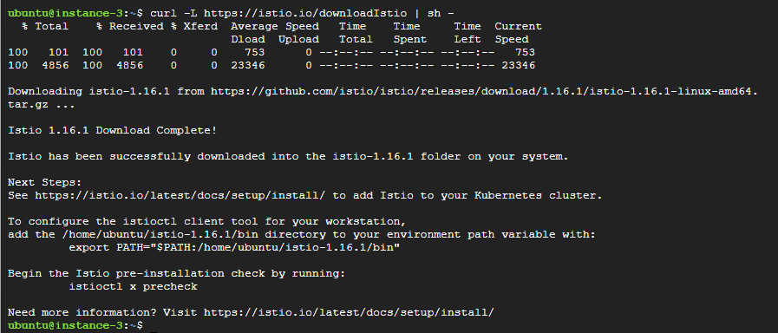

Move to the Istio package directory. For example, if the package is istio-1.16.1:

cd istio-1.16.1

Add the istioctl client to your path (Linux or macOS):

export PATH=$PWD/bin:$PATH

cd ..

istioctl install --set profile=demo -y

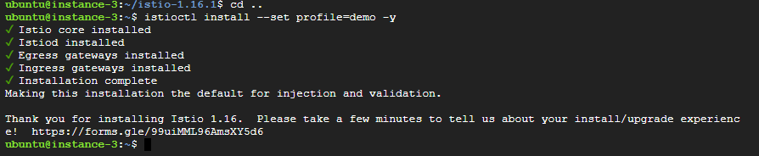

kubectl label namespace default istio-injection=enabled



kubectl apply -f - << END

apiVersion: networking.istio.io/v1alpha3

kind: Gateway

metadata:

name: seldon-gateway

namespace: istio-system

spec:

selector:

istio: ingressgateway # use istio default controller

servers:

- port:

number: 80

name: http

protocol: HTTP

hosts:

- "*"

END

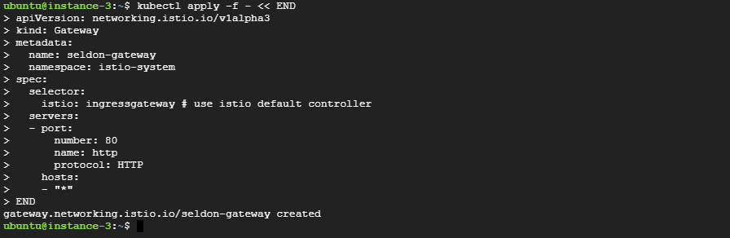

kubectl create namespace seldon-system



helm install seldon-core seldon-core-operator \

--repo https://storage.googleapis.com/seldon-charts \

--set usageMetrics.enabled=true \

--set istio.enabled=true \

--namespace seldon-system

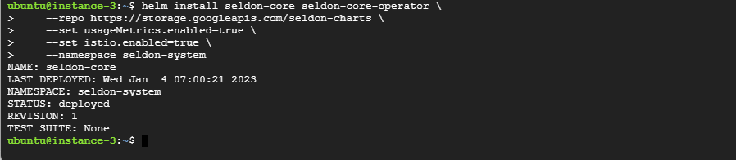

kubectl get pods -n seldon-system



kubectl get -n istio-system svc/istio-ingressgateway





Please note port connected to 80- This case it is 30482[Note: might be you will get different port number]

**Appendix 5**

**Install Swarm Learning on GCP Ubuntu VM**

Step 1- Go to <https://console.cloud.google.com/> and select Project:- GCPTraining7 if not selected already

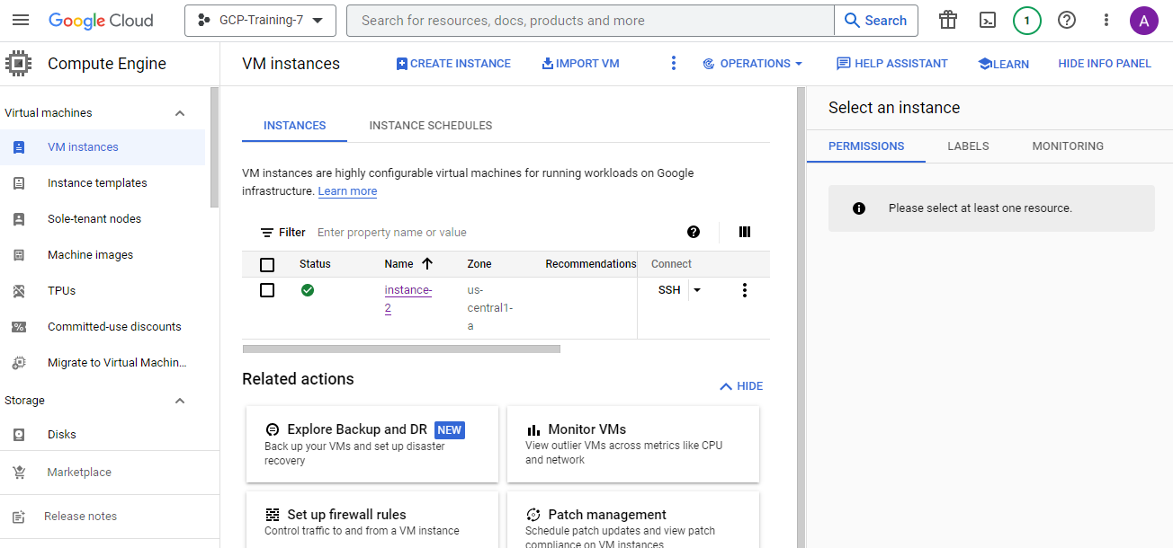

Step 2 – Click on VM instances and start the instance and copy external IP address

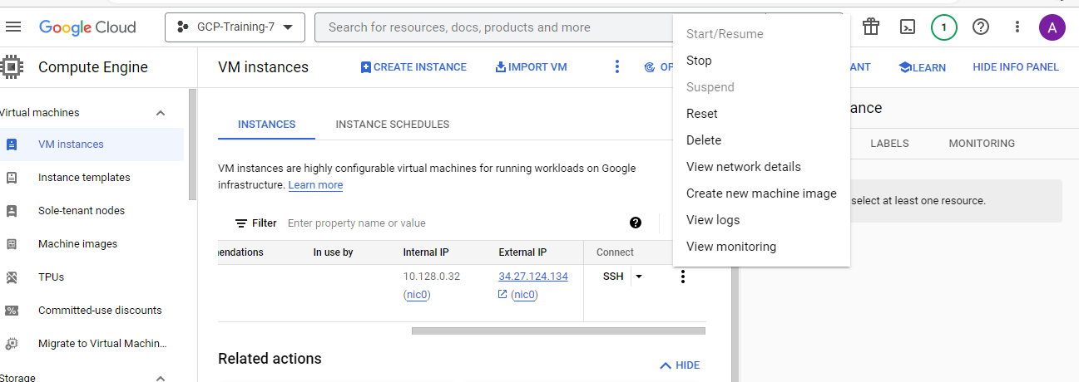

Step 3- Start Remote Desktop Connection, paste external IP while connecting, click on connect and yes for certificate warning

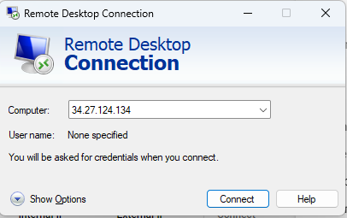

and put username and password to log in into instance. You will see the Ubuntu desktop

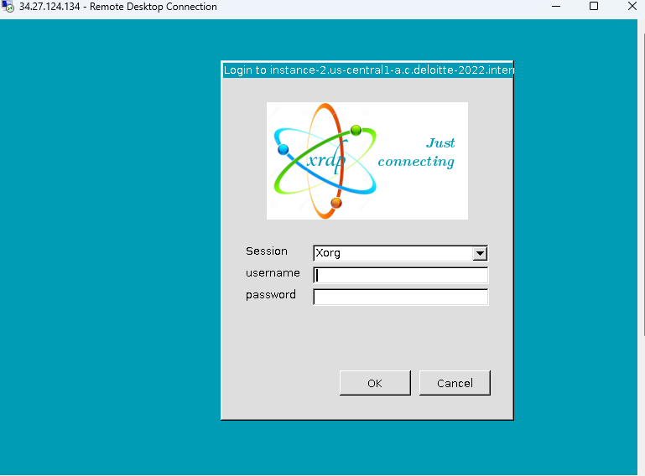

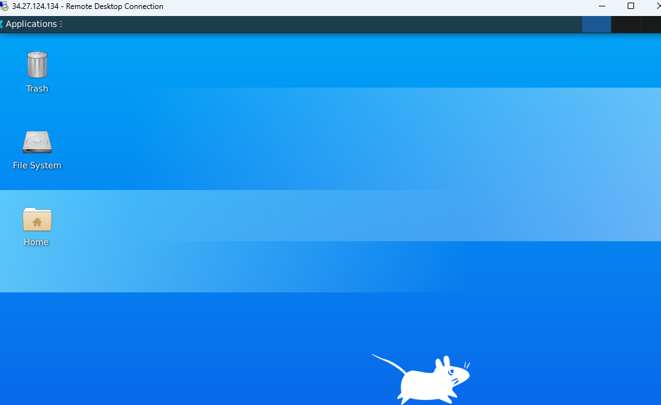

**Part 1 – Download the License Server**

Step 1 - Go to [https://myenterpriselicense.hpe.com](https://myenterpriselicense.hpe.com/) – HPE My Software Centre and Click on **create account** [use your personal Email Id]

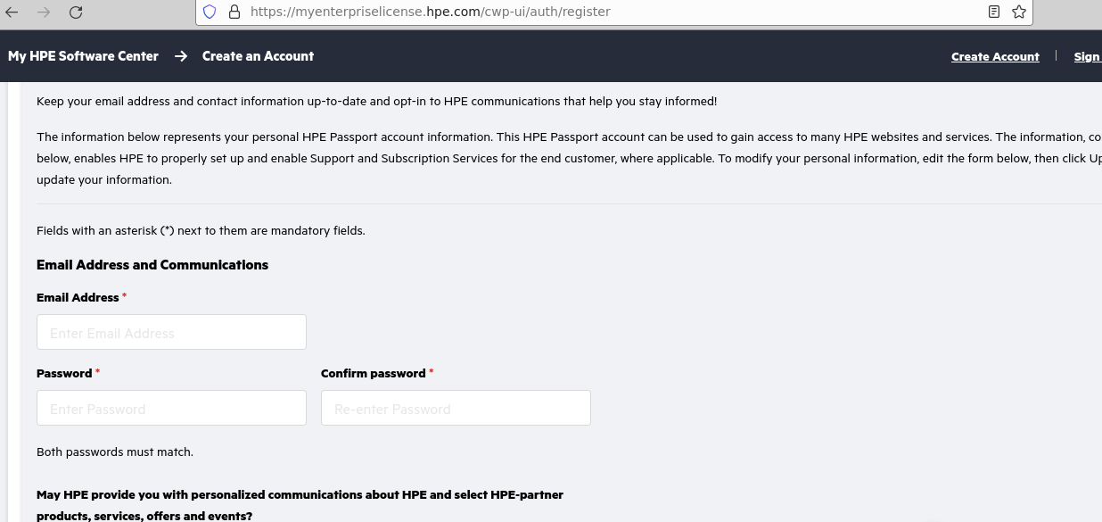

Step 2: After log in **Click on Software** from left hand side menu list

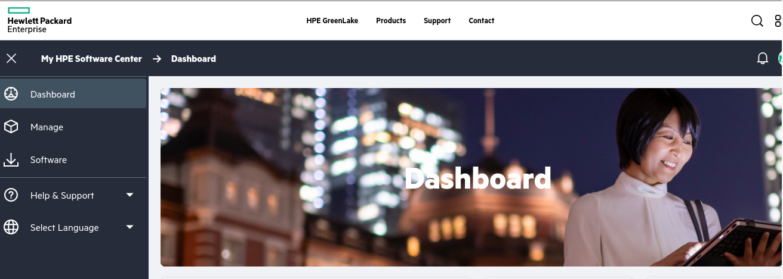

Step 3- In product Info Search for apls

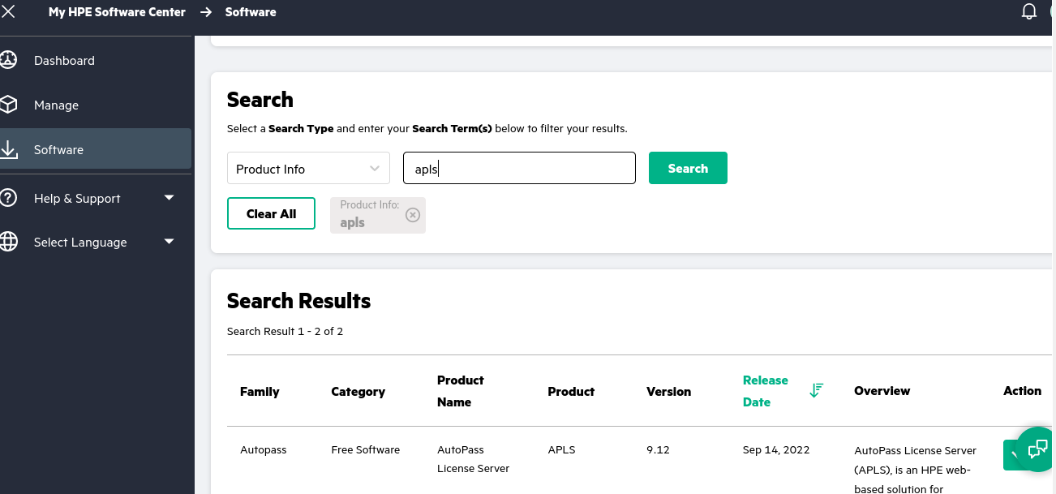

Step 4- Click on Action widget in front of **Free software APLS 9.2** and Click on Get Downloads

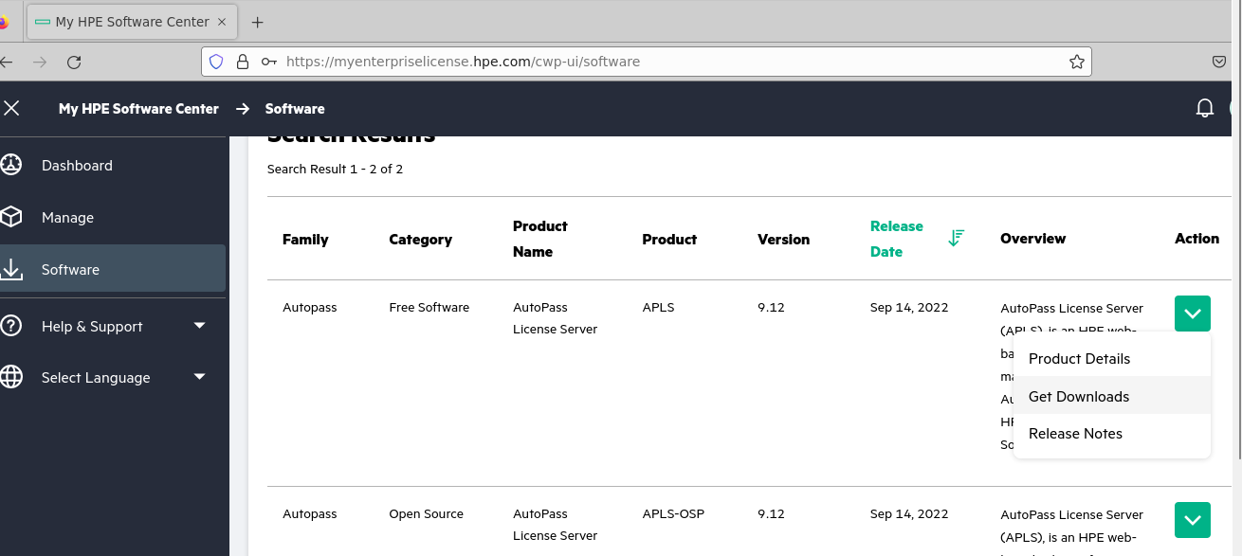

Step 6- Click on Download and your download will begin [471 MB]

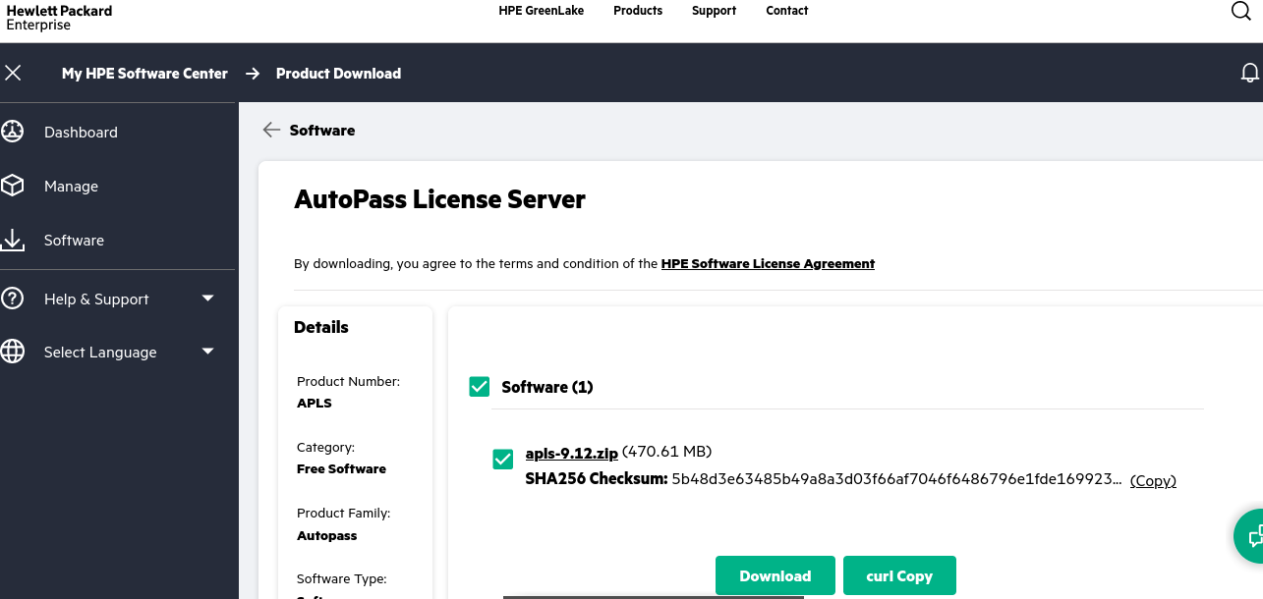

Step 7: open new terminal and execute following commands

**sudo apt install unzip / sudo yum install unzip**

**cd Downloads**

**unzip apls-9.12.zip -d /home/amits/apls9.12**

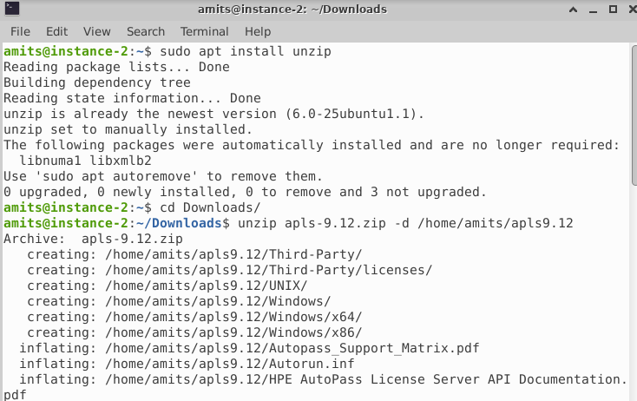

**cd /home/amits/apls/ UNIX/**

**chmod +x ./setup.bin**

**sudo ./setup.bin [If the installer is not running then try using root user]**

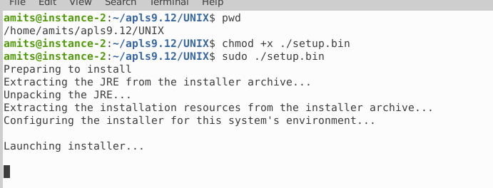

At the end you will see following lines printed

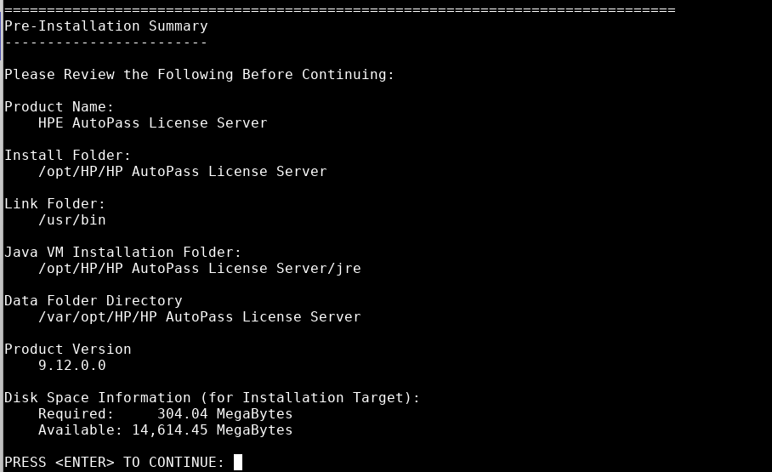

PRESS <ENTER> to start installation

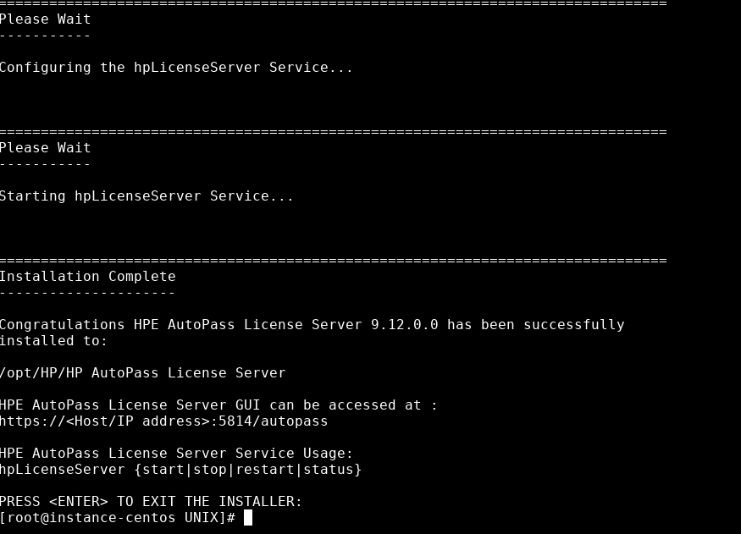

Step- 8 Execute Following Commands

cd /home/amits/

cd /opt/HP/

cd 'HP AutoPass License Server'/

cd 'HP AutoPass License Server'/

cd 'HP AutoPass License Server'/

cd bin

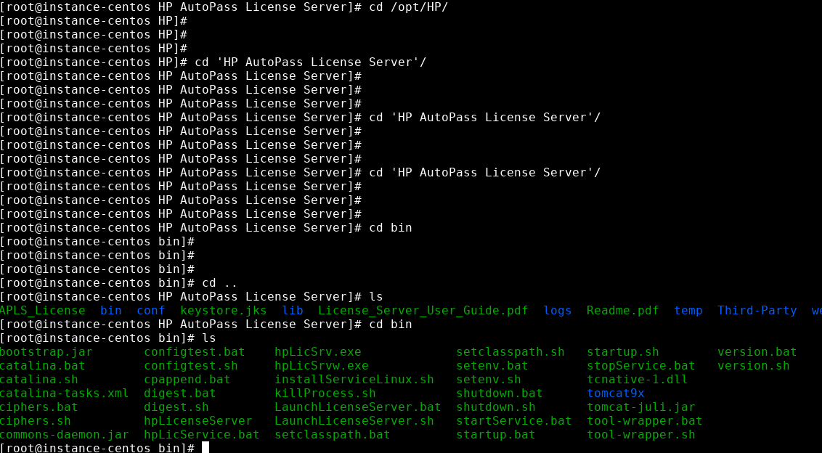

And execute command to start APLS

**./hpLicenseServer start**

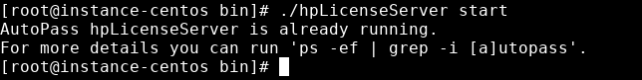

Your APLS Server started successfully.

Step – 9 Open Firefox new browsing tab and enter url - [https://localhost:5814](https://localhost:5814/)

[it might ask - Warning: Potential Security Risk Ahead click Advanced tab

it will extend dialog – localhost:5814 uses invalid certificate -ignore and click on – Accept Risk and Continue]

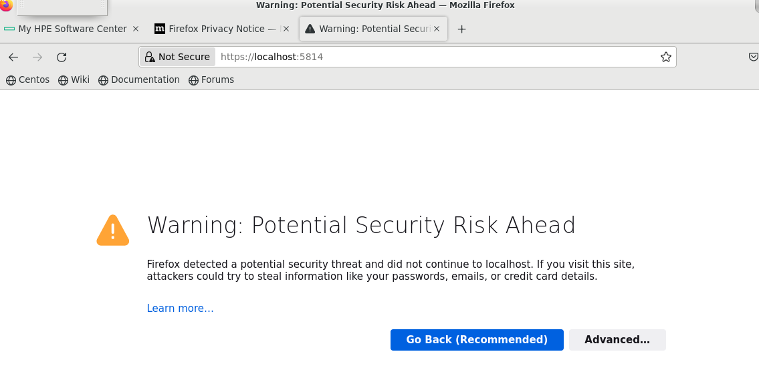

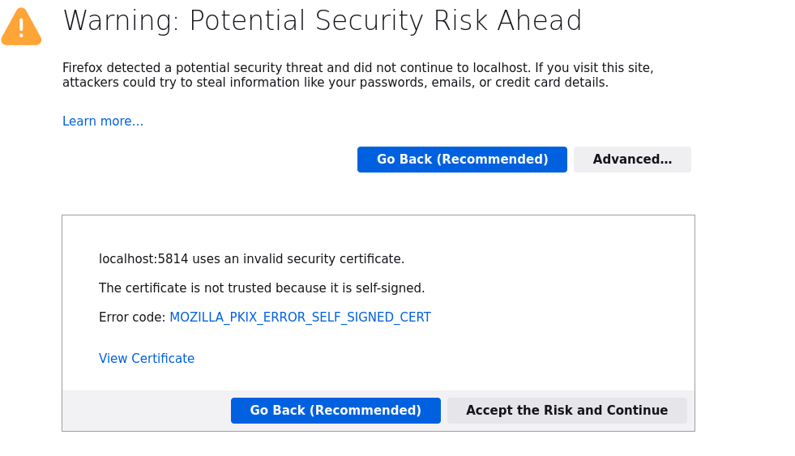

it will take you to login input page

username – admin

password – password

Click on LOGIN

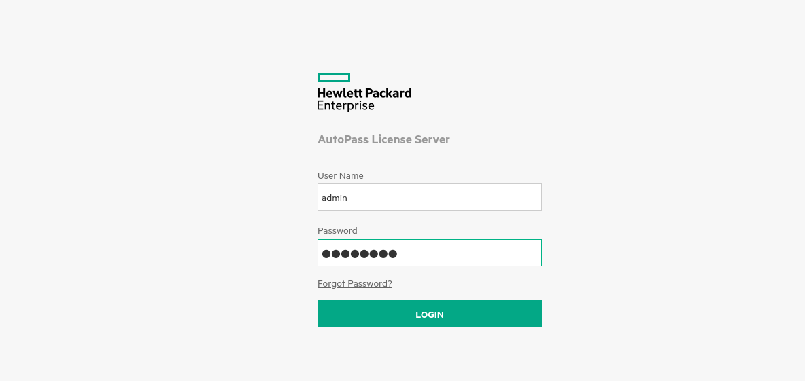

It will ask you to change password

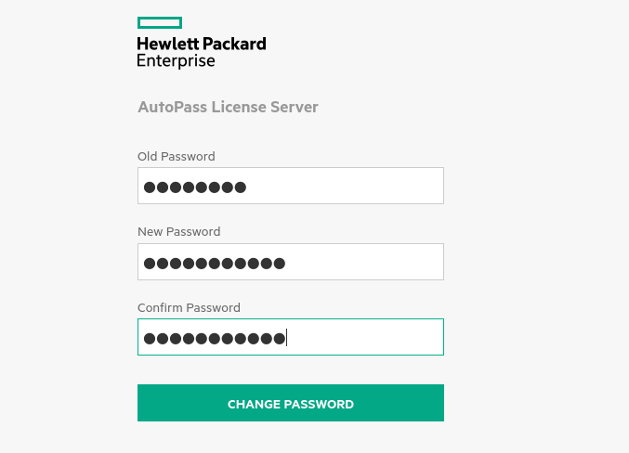

Please remember new password and after clicking on CHANGE PASSWORD , You will be redirected to following page

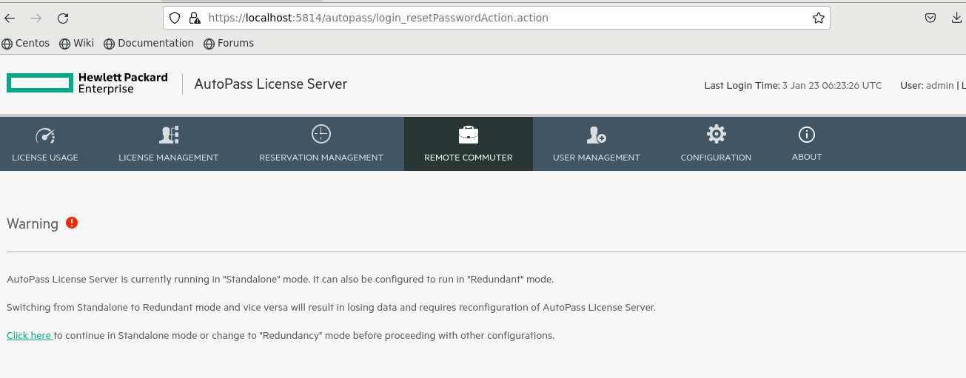

Step 10- click on LICENSE MANAGEMENT and then Click on Install Licence [Note Lock Code]

[ Ex. Lock Code: F671E87-EC8EA2A] This is your HPE Serial number

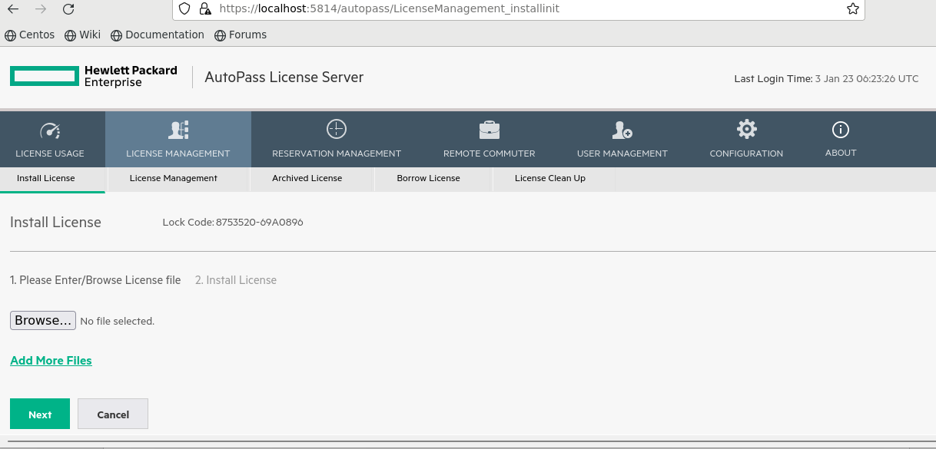

Step 11- Go back to your HPE Software Centre( [https://myenterpriselicense.hpe.com](https://myenterpriselicense.hpe.com/)), if not logged in – please login with HPE credentials and click on software and search ‘swarm learning’ in product info search bar

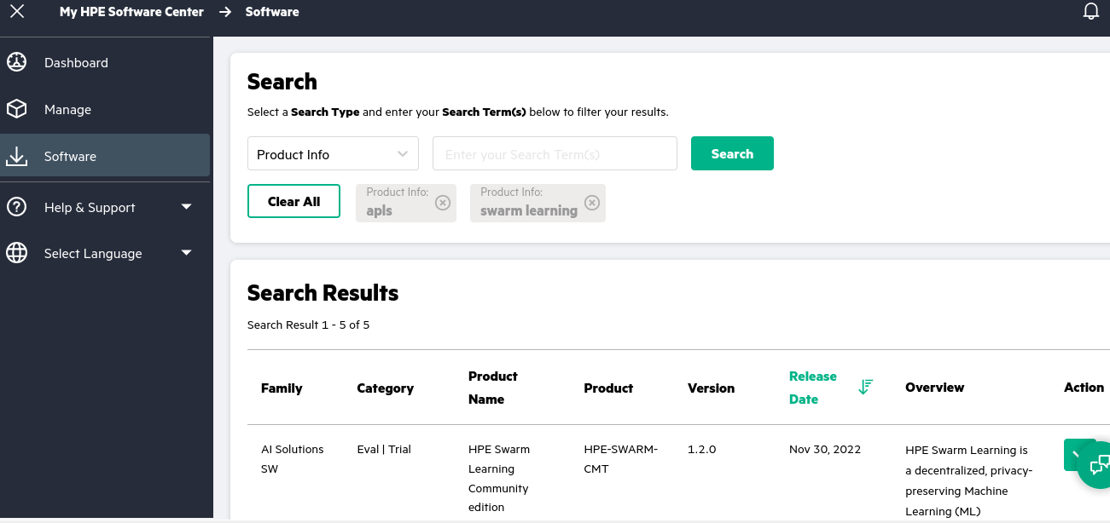

Step 12- In front of HPE swarm Learning Community edition, version 1.2.0, Click on Action Button and Click on Get License

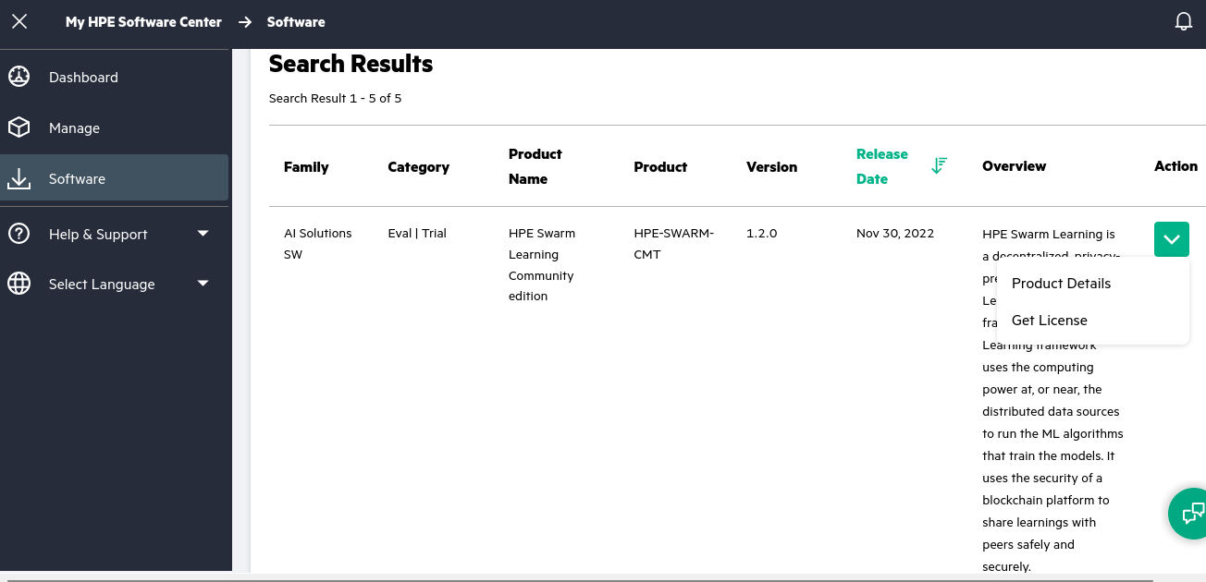

It will display following dialogue, Click on Next

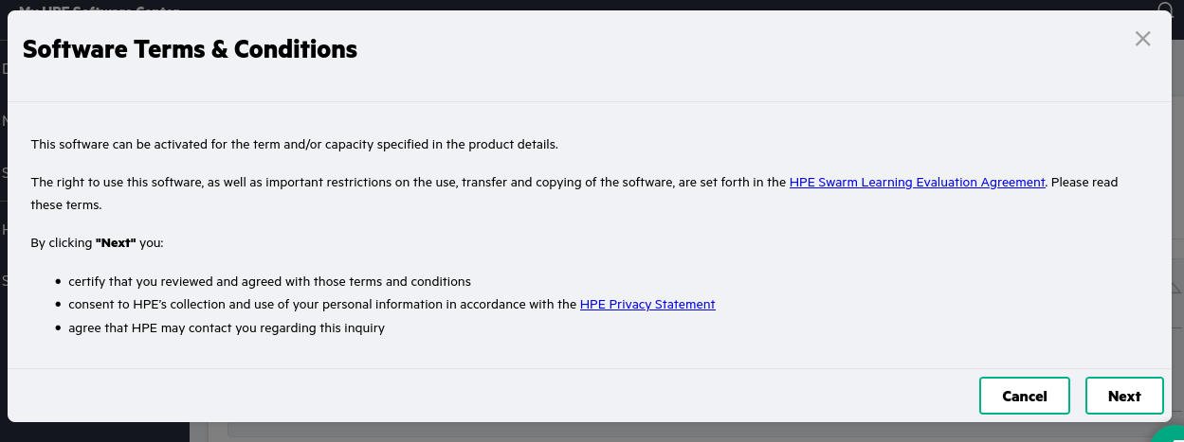

You will see the activate EON page

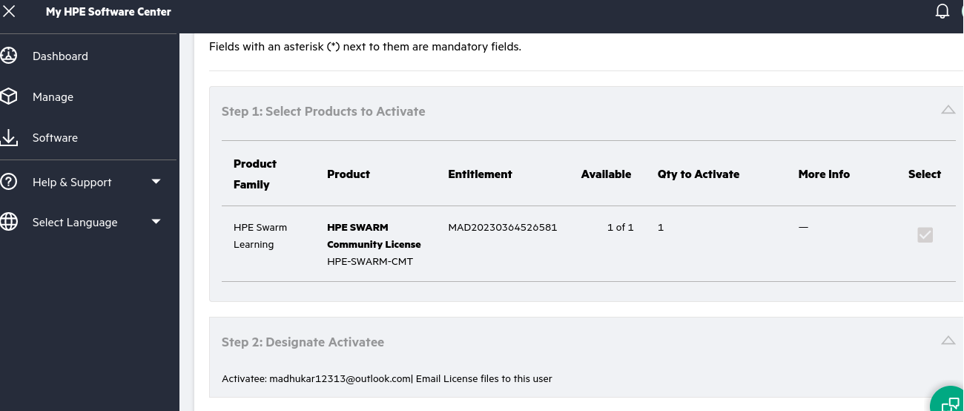

Step 13- Scroll down to step 3 and Enter your lock code in – HPE serial number field scroll below

click on Activate

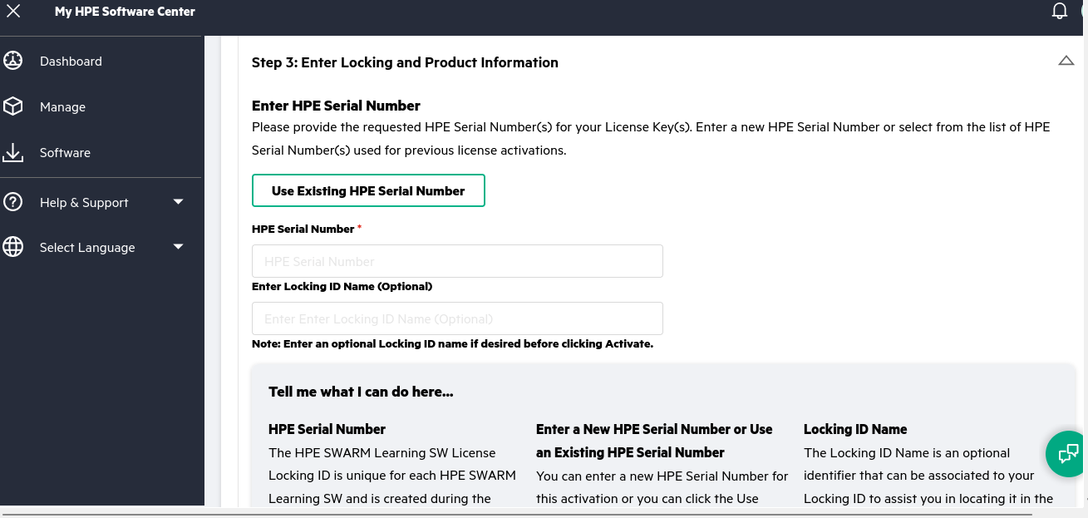

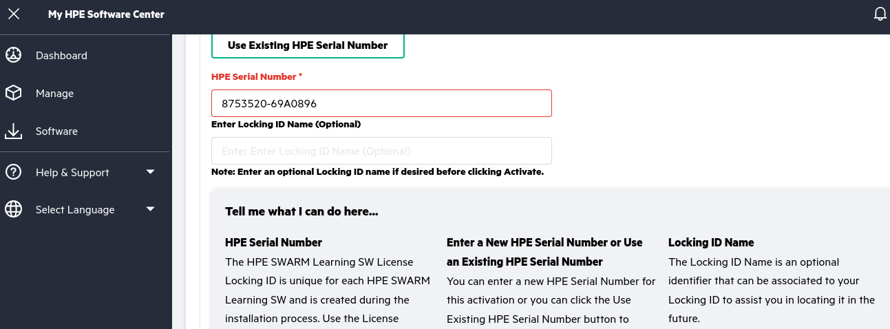

Scroll down and click on Activate

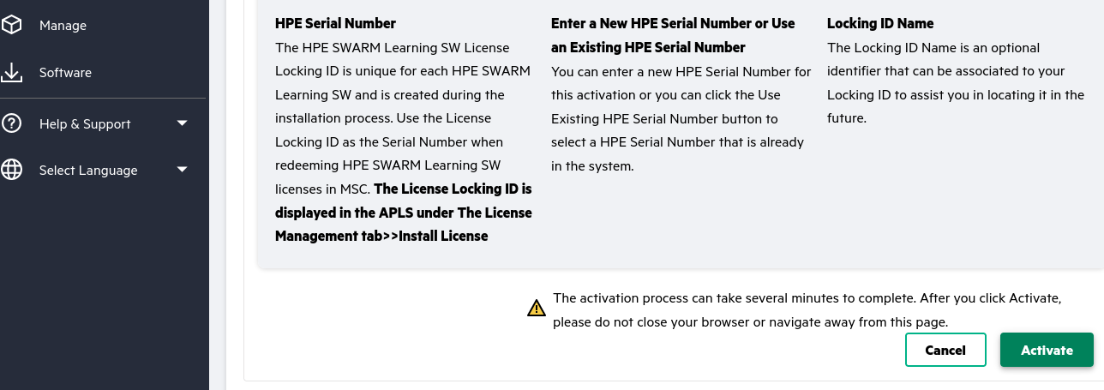

The activation process can take several minutes to complete. After you click Activate, please do not close your browser or navigate away from this page.

After successful activation,it will take you to HPE Swarm Learning community licence page

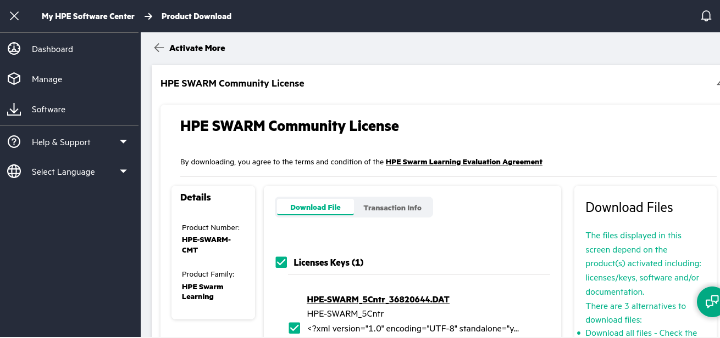

Step 14- Below Download file tab you will see the License keys(1)and Sofware (7) are listed

Please check in the box Infront of software (7) and click download and wait till download gets completed [Disable popup blockers]

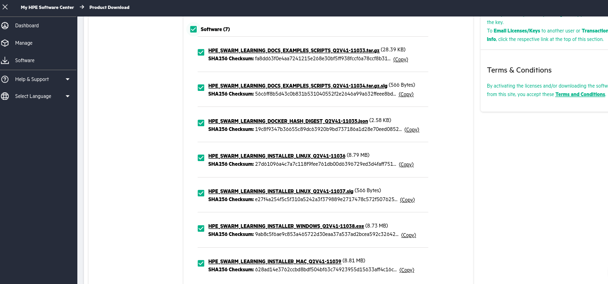

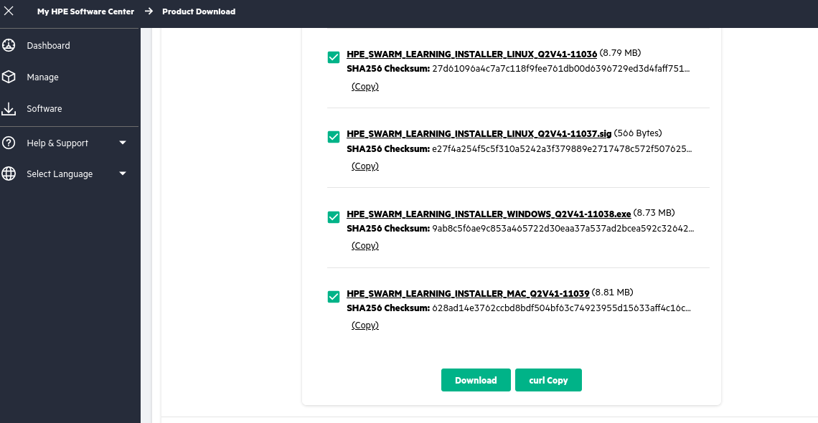

Step 16- After completion of download, Go to Downloads folder and see all the files

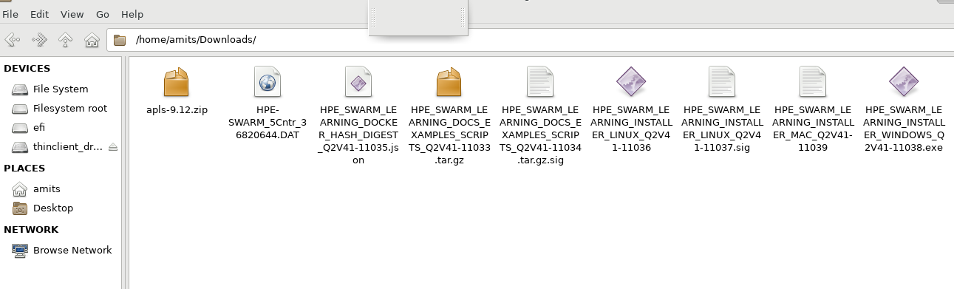

Step 17- Go back to your Auto pass license server browser Tab from where we have copied the Lock Code and click on browse button under Install Licenses

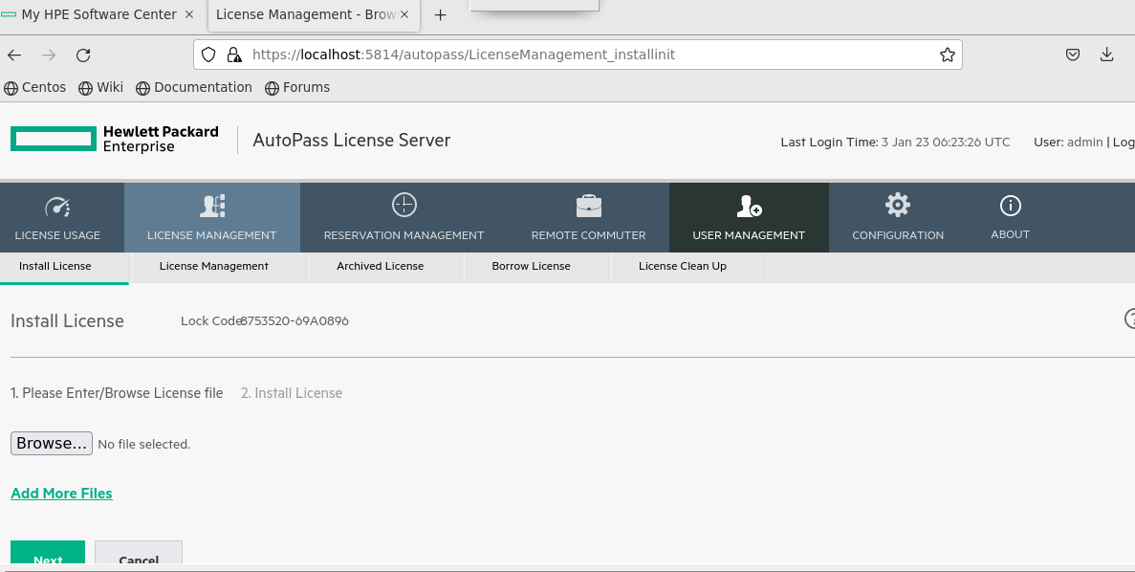

Step 18- select ‘HPE-SWARM_5Cntr_********.DAT’ file from download folder and click next

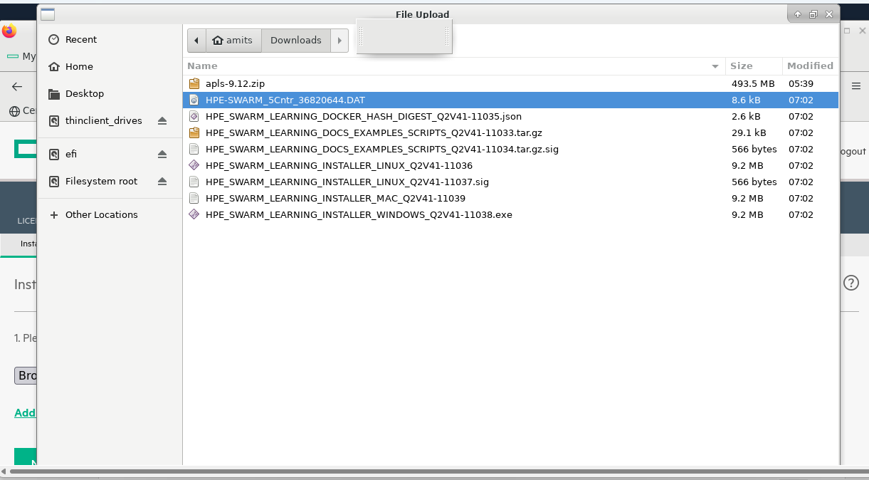

And Click on Next

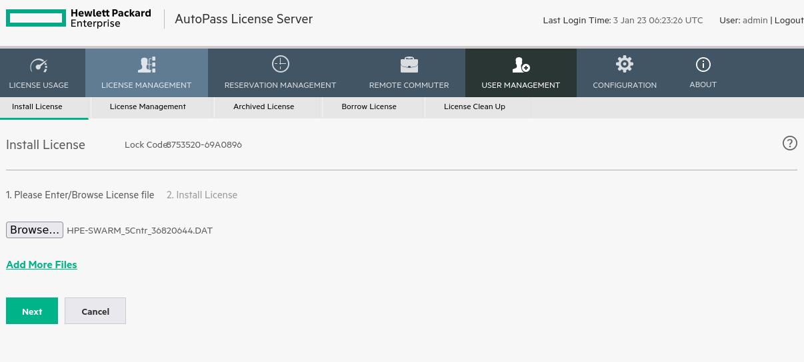

Step 20- select all four licenses – check in all four boxes and click on Install Licenses

You will see 1100000390:1 1100000388:1 1100000:378:1 1100000380:1 licenses successfully installed.

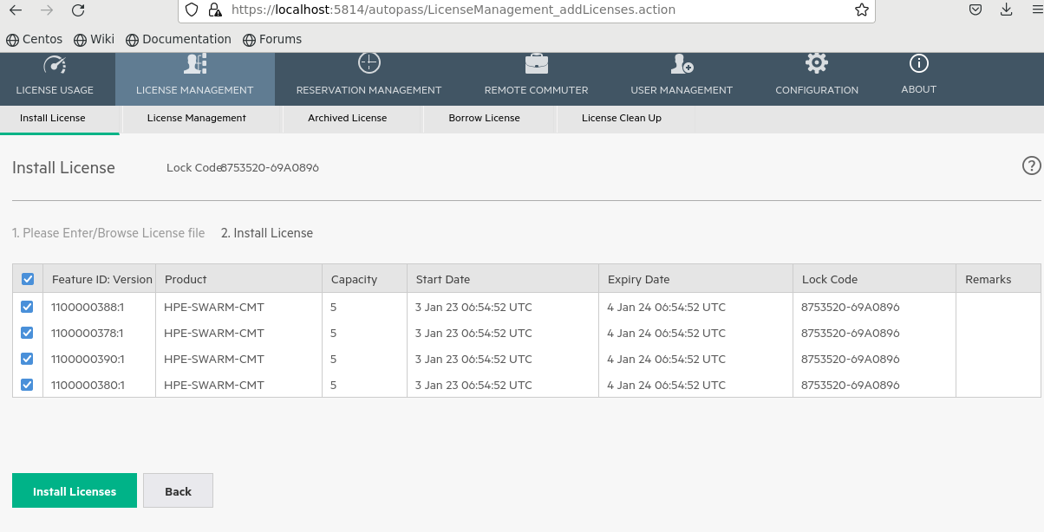

After Clicking on Install Licenses, you will see following page saying

“4 licenses added successfully “

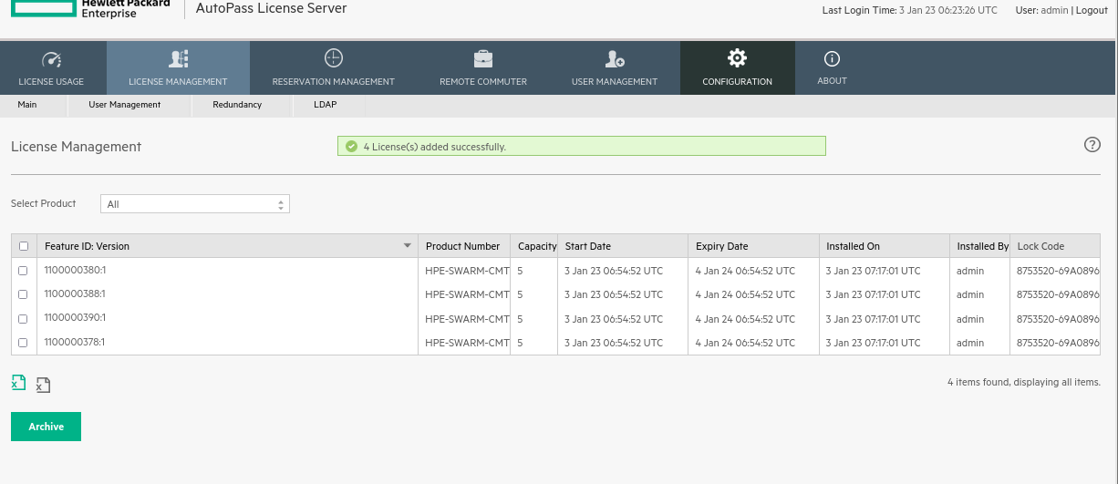

Step 21- Now Create folder to install swarm learning and run swarm learning installer for linux

Execute following commands

mkdir /home/amits/hpe

cd /home/amits/hpe

mkdir swarm-learning

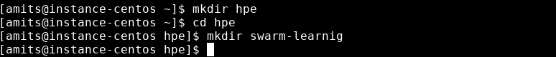

cd /home/amits/Downloads

chmod +x HPE_SWARM_LEARNING_INSTALLER_LINUX_Q2V41-11036

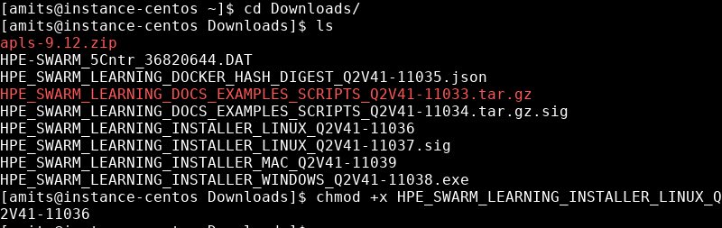

Step 22- From file manager/explorer **Double click** on executable file names as **HPE_SWARM_LEARNING_INSTALLER_LINUX_Q2V41-11036**

It will open WebUI installer in browser [if not then open new browsing tab – and Enter URL 127.0.0.1:30302]

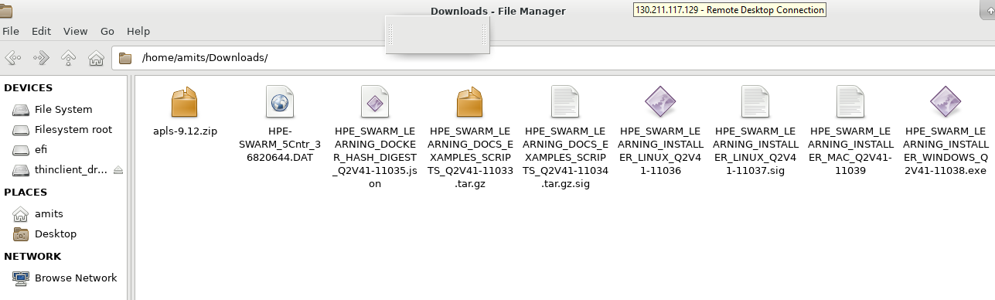

Click on Next

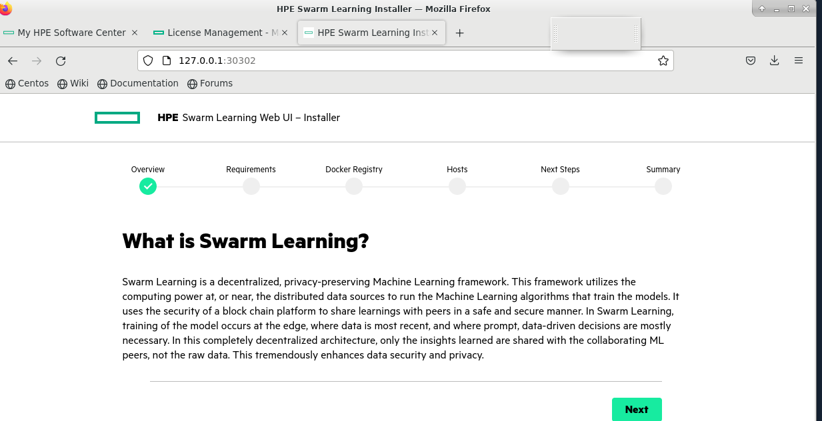

Scroll down and Click on Next

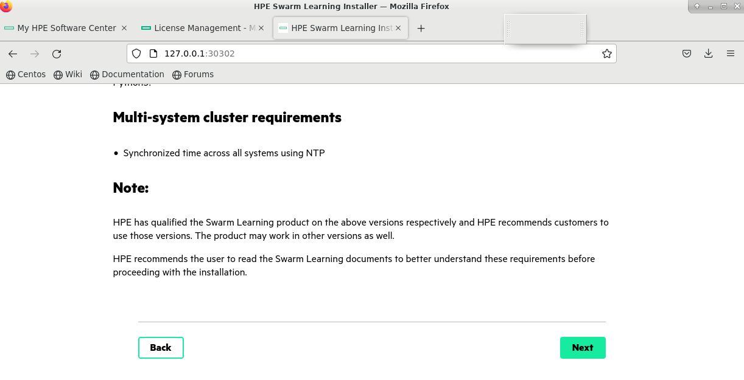

After that Enter your HPE Passport Username (Email-Id) and click on Next

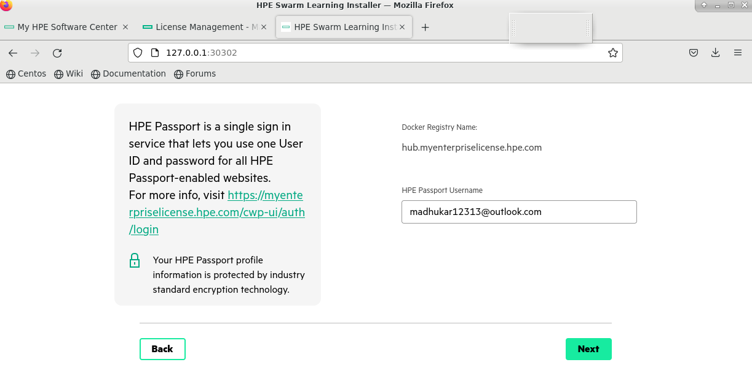

Enter directory path to install swarm learning and enter Internal IP [Private IP of Machine] with username and password

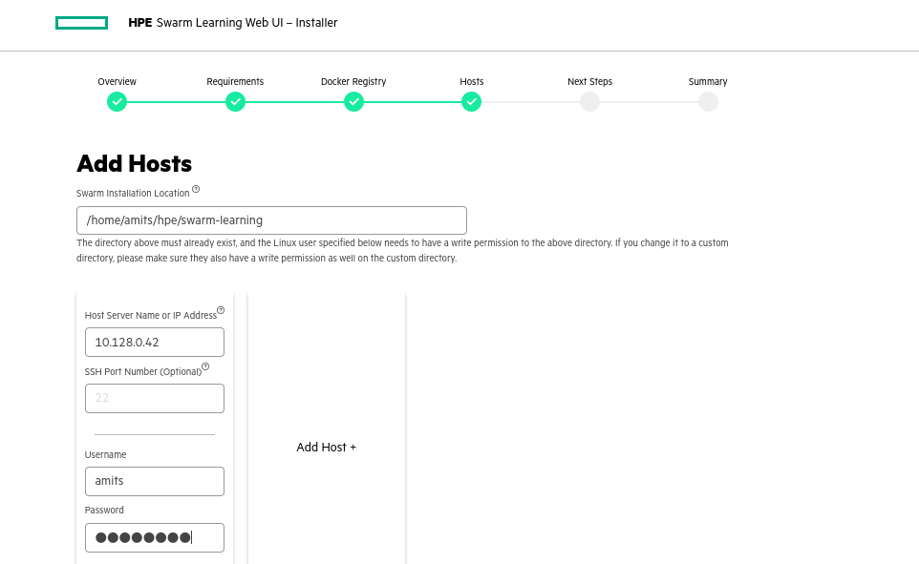

And Click on Next

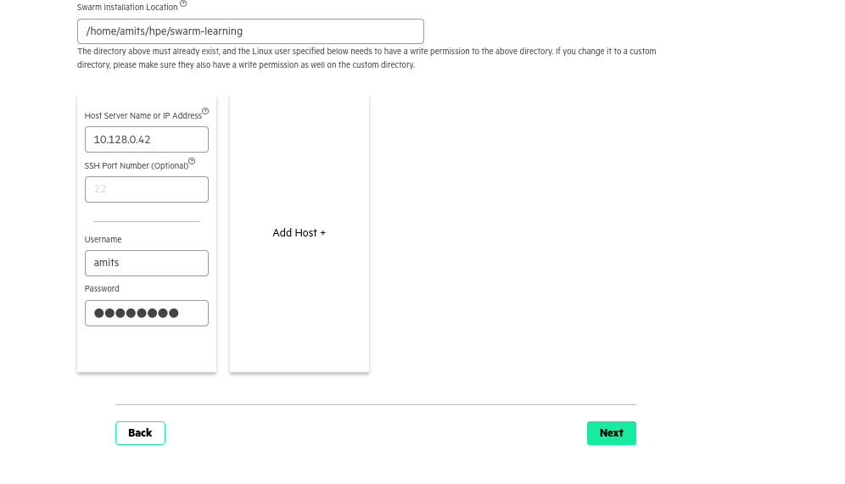

If there is an error message, click **Click here for more info**. Close the error message dialog, **Retry** or **Configure** the host, and click **Next**.

**Click Next**

Review **Next Steps** and click **Next**.

Review the **Summary** screen, which displays all the installed hosts. Click **Finish**.

An installation confirmation message is displayed. Click **Close Window**.

After successful installation, the Swarm Learning docker containers are installed on each of the host; the documentation, the sample code, and the scripts for running Swarm Learning are installed in the Swarm installation location (the default location is (/opt/hpe/swarm-learning))

**If web UI installer is giving some issues you can go for manual installation process**

1. As we have already downloaded the following file from HPE My Support Center(MSC) on a host system (HPE_SWARM_LEARNING_DOCS_EXAMPLES_SCRIPTS_Q2V41-11033.tar.gz) and the signature file for the above tar file.
2. Untar the tar file under /opt/hpe/swarm-learning.

Sudo tar -xzvf HPE_SWARM_LEARNING_DOCS_EXAMPLES_SCRIPTS_Q2V41-11033.tar.gz -d /home/amits/hpe/swarm-learning

If this command giving any error, you can execute following commands

Cd Downloads

Sudo tar -zxvf HPE_SWARM_LEARNING_DOCS_EXAMPLES_SCRIPTS_Q2V41-11033.tar.gz

You will find lib folder after extracting above file, copy it in /home/amits/hpe/swarm-learning manually or using following command

1. Do a docker login from your machine terminal:

 docker login hub.myenterpriselicense.hpe.com –u <YOUR-HPE-PASSPORT-EMAIL> -p hpe_eval

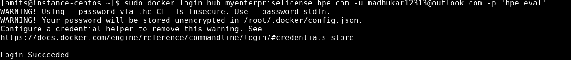

1. Pull the signed Swarm Learning images from HPEs Docker Trust Registry (DTR):

docker pull hub.myenterpriselicense.hpe.com/hpe_eval/swarm-learning/sn: 1.2.0

docker pull hub.myenterpriselicense.hpe.com/hpe_eval/swarm-learning/sl: 1.2.0

docker pull hub.myenterpriselicense.hpe.com/hpe_eval/swarm-learning/swci: 1.2.0

docker pull hub.myenterpriselicense.hpe.com/hpe/swarm-learning/swop: 1.2.0 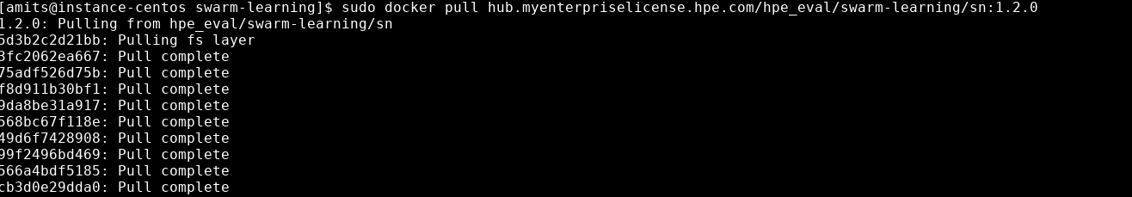

This completes the swarm learning installation.